HOUSING

Carrabassett Valley is a highly desirable place to call home. Like many places in Maine, particularly those with seasonal recreation and tourism economies, year-round and seasonal workforce housing is a challenge. Construction costs and the demand for second home and short-term rentals are two of the many reasons why affordable housing is challenging to build in these areas. This chapter inventories the amount and type of housing, assesses the pattern of development, and analyzes the affordability of housing in Carrabassett Valley.

KEY FINDINGS

- The majority of housing units in Carrabassett Valley are single-family detached, though there are a high number of multi-family units for a rural town of this size, due to the presence of a major resort and recreational opportunities, and the type of housing built to support that industry.
- The percentage of vacant units in 2020 (83.4%) has decreased overall since the year 2000 (89.3%), but increased slightly between 2010 – 2020, from 82.3% to 83.4%.
- While Carrabassett Valley has fluctuated between “affordable” and “unaffordable” in the past decade, recent data from MaineHousing shows that since 2021 Carrabassett Valley has become deeply unaffordable to those making the median income.
- There is a shortage of housing affordable to those in the year-round or seasonal workforce.
- Western Maine Mountain Housing is a collaborative effort of Carrabassett Valley and four surrounding communities to build new housing attainable to the year-round and seasonal workforce.
- The 2022 Regional Workforce Housing Needs Assessment and Strategy is an important resource for understanding local conditions, trends, needs, and provides strategies to address the demand for additional housing types and price points.

STRATEGIES FROM PREVIOUS PLAN

- Page 39: LAND USE 6. Allow mobile home parks in the Planned Unit Development District in accordance with state standards.
- Page 44: HOUSING 1. Work with private developers and employers to develop affordable employee housing and affordable rental housing

OVERVIEW

Housing Snapshot
CV Housing Units | 2000 | 2010 | 2020
Total Units | 1,675 | 2,103 | 2,138
Occupancy | 2000 | 2010 | 2020
Total Housing Units | 1,675 | 2,103 | 2,138
Occupied | 179 | 373 | 354
Vacant | 1,496 | 1,730 | 1,784
Housing Type (Decennial and ACS Data) | 2000 | 2010* | 2022*
SF detached | 46.1 | 90.2% | 66.3%
SF attached | 1.5 | 0.0% | 4.1%
Multi-family | 52.4 | 9.8% | 29.5%
Tenure | 2000 | 2010 | 2020
Total Units | 1,675 | 2,103 | 2,138
Occupied | 179 | 373 | 354
Owner-occupied | 145 | 325 | 354
Renter-occupied | 34 | 48 | 1,784
*The U.S. Census Bureau no longer captures housing type in the Decennial Census count and instead now provides this data point as part of the American Communities Survey (ACS) 5-year estimates. The 2022 data reported adds up to 99.9%, which may be a small reporting or rounding error by the ACS.

Since the town’s incorporation in 1972, Carrabassett Valley has continued to grow. According to the 2020 U.S. Decennial Census, there were 2,138 total housing units, a modest increase from 2010 and more substantial increase from the year 2000. Occupied housing units declined and vacant housing units increased. Between 2010 and 2022 the percentage of single-family homes declined significantly while the percentage of multi-family homes rose significantly. This may reflect the continued construction of seasonal condo or townhouse-style lodging at or close to Sugarloaf Mountain Resort. In addition, renter-occupied housing increased dramatically, which owner-occupied housing remained constant.

HOUSING CHARACTERISTICS

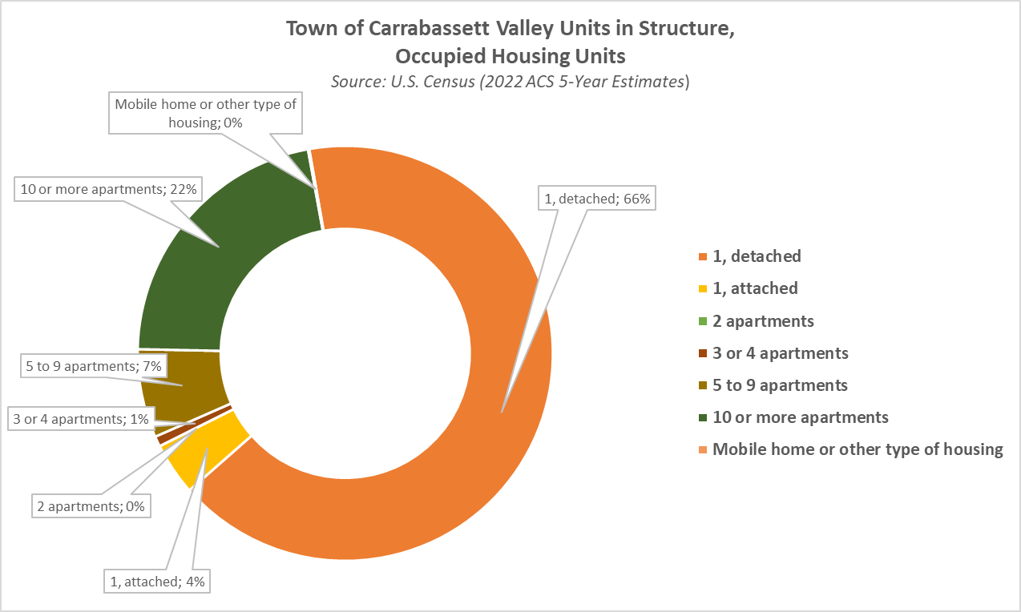

According to the American Community Survey 2022 estimates, the majority of occupied housing units in the Town of Carrabassett Valley are single-family detached (66.3%), with the next highest percentages being 10 or more apartments (21.8), and 5 to 9 apartments (6.9%), and duplexes (4.1%). The relatively high concentration of multi-family housing units (32.8%) for a small, rural town is understandable considering the presence of a major ski resort and recreational tourism destination where there is typically very high demand to stay on the mountain and the resulting development is condos and townhomes.

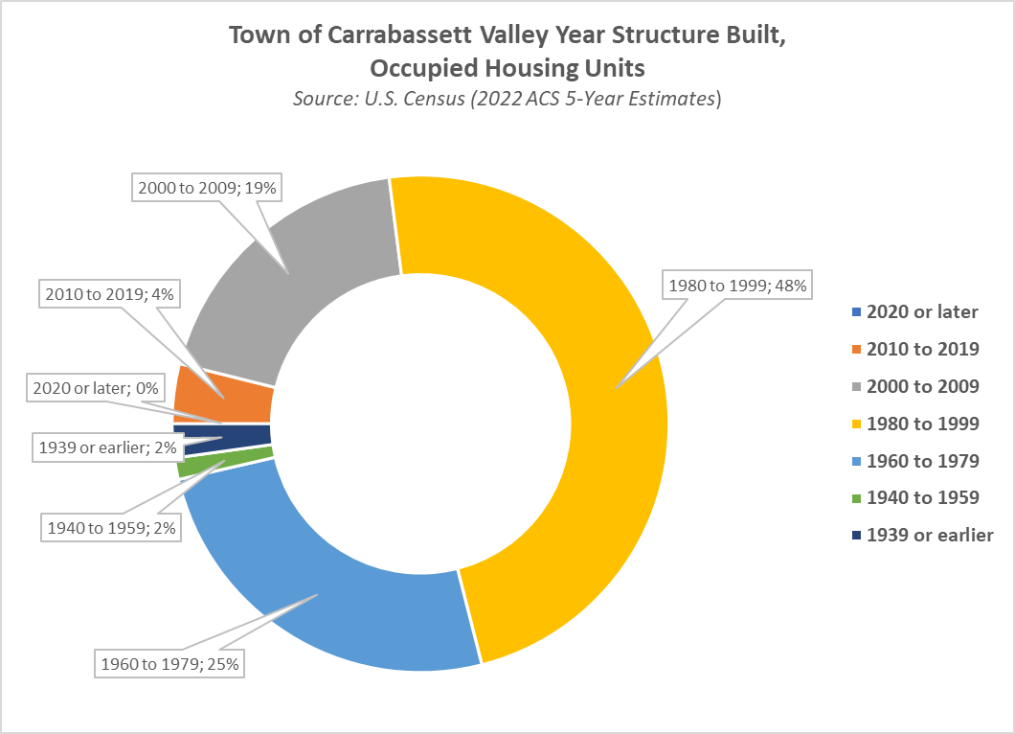

The housing inventory has increased significantly since the early 1980s. As shown in the chart above, the majority of housing – almost 70% – in the Town of Carrabassett Valley was built in the thirty-year time span between 1980 – 2009. During the height of the building boom (1980s and 1990s), about seven out of every ten new units were built on Sugarloaf Mountain.

The result is a pattern of housing development that paralleled the development of the town as a recreational resort destination. It is possible to trace the town’s history from the location and architecture of its housing. It has proceeded from a nascent wilderness ski area supported by visitors in no-frill A-frames in the lower valley, to the modified Acorn homes in Redington at a time when the Dead River Company was a moving force behind the area’s development, and finally to a year-round resort whose lifeline is very much connected to the condominiums and custom homes which are within walking distance of Sugarloaf Mountain’s ski lifts and golf course.

The Town of Carrabassett Valley primarily relies on propane (42%) and oil (36.2%) for heating fuel, along with “all other fuels” (11.6%) and electricity (8.8%). A very small number of housing units use utility gas for heat (1.4%). No housing units were reported as having “no fuel used” or as using coal or coke.
HOUSING TENURE AND VACANCY

Tenure

Housing Tenure in Carrabassett Valley 2000 – 2020.
Source: U.S. Census Bureau Decennial Census.
Year | Total Occupied Housing Units | Owner-Occupied | Renter-Occupied | Percent Owner | Percent  Renter
2020 | 354 | 309 | 45 | 0.87 | 0.13
2010 | 373 | 325 | 48 | 0.87 | 0.13
2000 | 179 | 145 | 34 | 0.81 | 0.19

Vacancy

Housing Vacancy in Carrabassett Valley 2000 – 2020.
Source: U.S. Census Bureau Decennial Census.
Year | Total Housing Units | Occupied | Vacant | % Occupied | % Vacant
2020 | 2,138 | 354 | 1,784 | 16.6% | 83.4%
2010 | 2,103 | 373 | 1,730 | 17.7% | 82.3%
2000 | 1,675 | 179 | 1,496 | 10.7% | 89.3%

Since 2000, the percentage of owner-occupied housing units has risen slightly from 81% to 87% in 2000 and the ratio remained constant in the data reported in the 2020 U.S. Decennial Census. In the same time span, the percentage of vacant units has declined slightly from 89.3% to 83.4%. The U.S. Census Bureau defines a housing unit as vacant “if no one is living in it at the time of the interview, unless its occupants are only temporarily absent. In addition, a vacant unit may be one which is entirely occupied by persons who have a usual residence elsewhere.” This high percentage of vacant units speaks to the town as a popular recreation destination with a major ski resort, with many second homes or rental units on and near the mountain.

AFFORDABILITY

Affordability Index Scores and Associated Data for Carrabassett Valley between 2006 – 2022.
Source: MaineHousing Affordability Index.
Year | 2006 | 2010 | 2015 | 2020 | 2022
Affordability | Unaffordable | Unaffordable | Affordable | Affordable | Unaffordable
Affordable Homes Sold | 7 | 7 | 63 | 22 | 0
Home Price Affordable to Median Income | $164,419 | $128,743 | $293,348 | $306,732 | $239,170
Households Unable to Afford Median Home | 105 | 124 | 178 | 203 | 387
Households Unable to Afford Median Home (%) | 55.3% | 68.5% | 47.5% | 47.4% | 89.6%
Income Needed to Afford Median Home Price - Annual | $55,455 | $57,495 | $70,313 | $69,202 | $202,488
Income Needed to Afford Median Home Price - Hourly | $26.66 | $27.64 | $33.80 | $33.27 | $97.35
Index | 0.89 | 0.68 | 1.05 | 1.06 | 0.34
Median Home Price | $185,000 | $190,000 | $279,000 | $289,500 | $710,000
Median Income | $49,286 | $38,958 | $73,929 | $73,321 | $68,210
Percentage of Unattainable Homes Sold | 61.1% | 74.1% | 32.3% | 47.6% | 100.0%
Total Households | 190 | 181 | 374 | 429 | 432
Unattainable Homes Sold | 11 | 20 | 30 | 20 | 30

MaineHousing, the Maine State Housing Authority, produces housing affordability index that indicates if an area is considered affordable or unaffordable based on the ratio home prices that are affordable to the median income and the actual median home price. An index of less than “1” means the area is generally unaffordable, which means that a household earning area median income could not cover the payment on a median priced home (30-year mortgage, taxes, and insurance, using no more than 28% of gross income).

The table above shows MaineHousing Affordability Index data from select years between 2006 – 2022. According to the index, in 2006 and 2010, there were only seven affordable homes sold in Carrabassett Valley, with the median home price around $190,000 and the median income listed as $49,628 and $38,958, respectively. In 2015 and 2020, the index lists Carrabassett Valley as affordable, with higher median home prices (in the high $200,000 range) but also higher median incomes around $73,000. Two years later, in 2020, the median income declined and the median home price went up dramatically from $289,500 to $710,000. The following graphs chart the MaineHousing Affordability Index for each year from 2006 to 2022 for Carrabassett Valley, and from 2000 - 2020 for Franklin County, and the state of Maine. The final graph shows the three lines together.

CURRENT ANALYSES, PARTNERSHIPS, AND INITIATIVES

Western Maine Mountain Housing

In the last several years, the Carrabassett Valley Regional Housing Committee worked together with Camion Associates to produce the Regional Workforce Housing Needs Assessment and Strategy for the five towns of Carrabassett Valley, Eustis, Kingfield, Wyman Township, and Coplin Plantation (February 2022). The report confirmed that there is a strong unmet need for workforce housing in the study area, including rental units, homeownership units, and seasonal rooms, and provided specific data for those categories. Study findings also concluded:

- Local workers are largely priced out of the ownership market. Single-family homeownership is out of reach of many workers whose income does not allow them to afford the current sale price of most homes. Home prices have increased upwards of 25%-40% in the last few years, driven by high demand from seasonal visitors and second-home buyers.

- Workers also struggle to year-round/long-term rental units at attainable price points. Rental units are also seeing price increases that are pushing them beyond the means of local residents and workers. Rental price increases are driven in part by conversions of units from year-round or part-year rental housing to short-term rentals (STRs). Year-round rental units at any price point are in extremely short supply.

- Seasonal workforce housing is needed. The need for workers increases significantly in the winter months, driven by hiring at Sugarloaf. It was suggested that dorm-style seasonal housing would be well utilized in the local area, as well as other types of housing.

- The lack of rental housing is constraining hiring at local businesses. Businesses interviewed indicated that there is an urgent need for affordable/attainable rental housing units. Some businesses have been able to provide their own housing to employees, but more is needed. These trends are putting pressure on businesses across a variety of industry sectors to survive and grow.

- Zoning is a potential challenge to the development of workforce housing in the region. Local zoning often limits residential development to one unit per acre, precluding multifamily development. Multifamily housing could be delivered to prospective buyers and renters at lower price points, as land costs can be spread over multiple units and other economies of scale can be achieved.

Using the findings and recommendations from the Regional Workforce Housing Needs Assessment and Strategy, residents and business owners formed the Western Maine Mountain Housing (WMMH), a nonprofit volunteer collation founded to address this issue. The group states that “Making sure housing remains affordable in western Maine is, for us, a personal quest to preserve the character of the towns we love and make sure many more generations call western Maine home.”

WMMH is a non-profit dedicated to maintaining the economic and civic health of western Maine by creating permanently affordable, year-round workforce housing for individuals and families in Kingfield, Carrabassett Valley, Wyman Township, Coplin Plantation, and Stratton/ Eustis. They are based in Kingfield with board members from each of the affected towns. Their mission is “We will lead a process engaging communities and businesses to seek suitable sites, funding, and developers to create workforce housing for individuals and families.”

The coalition is currently pursuing construction of the first phase of the project. This first phase consists of two nine-unit multi-family buildings having a mix of one- and two-bedroom apartments in Kingfield, and they intend to have at least one workforce housing project in each of the five towns served by this coalition.

