RECREATION & OPEN SPACE

KEY TAKE-AWAYS

- Recreation is the top attraction and economic driver for Carrabassett Valley
- Visitors and seasonal and long-term residents are drawn to the town’s vast natural spaces, scenic beauty, and outdoor recreation opportunities
- There is a robust, longstanding, and symbiotic partnership between Sugarloaf and town management, including cooperatively owning and managing facilities
- The Town is dedicated to preserving and improving public recreation opportunities
- The Town has increasingly become a year-round recreation area
- The Town Park and pool are highly valued and utilized by the community
- There are significant efforts to create and improve mountain biking trails and make Carrabassett Valley a mountain biking hub
- The trail network has been expanded, as have trail maintenance efforts
- Trail access has been impacted by the closing of private lands in the last few years, including access to Huston Brook Falls and the Bigelow Preserve trails
- There aren’t many access points to water other than along the Carrabassett River. However, access to Flagstaff Lake in the Town of Eustis is 8.65 miles from the Sugarloaf Access Road.
- Climate change is already beginning to impact the recreation opportunities

RECOMMENDATIONS FROM 2003 COMP PLAN

Town Park Recommendations

- The basketball court needs to be repaved. The Playground needs to be rebuilt. The Town currently has $13,500 in the Playground Reserve Account. Preliminary cost estimates indicate that it will cost approximately $50,000 to complete both projects. The Committee is recommending that the town apply for 50% matching grant from the State’s Land and Water Conservation Fund next year, if funding is available, to complete these projects. The Committee indicated that this is a high priority project.
- The Town should undertake improvements that may be recommended in the pool assessment.
- The Committee supports repairing the Black Fly field for Little League, if a regional program warrants it in the future. Carrabassett Valley Academy has a need for a baseball field and there is some question as to whether or not the town has similar interest. Committee members suggested further research to determine if CVA can use their new soccer field and/or adjacent land for a baseball field.
- There was also some discussion about building a footpath/exercise training station area along the Narrow Gauge Pathway. The Committee suggests monitoring the need for this service in the future.
Anti-Gravity Complex Recommendation

  - The Committee is very satisfied with the current success of operations and programs but felt that the Town should closely monitor opportunities for future expansion.
New Indoor Pool Recommendation

- The Committee suggested that a study should be completed to determine capital and operating costs, potential revenues from all sources (including Sugarloaf’s marketing potential) and the feasibility of building a town-owned and operated indoor pool.

Golf Course Recommendations

- Short Term
  - The Irrigation System is 20 years old. It was state-of-the-art at that time—a study is needed to determine how best to cost effectively improve this system.
  - A Bank (Erosion Control) Stabilization Project is needed for the 11th Tee.
  - Explore the possibility of putting together a plan for building a new clubhouse through a partnership between the Town and SMC.
  - Look at completing minor improvements needed for the Maintenance Garage (“wash pads” and dry storage).
  - Continue to more aggressively market the Junior Golf Program.
- Long Term
  - Continue to look at making major improvements and expansions to the driving range.
  - Consider the need for the development of an additional 9 or 18 hole course.

Outdoor Center Recommendations

- The Committee unanimously agreed that a master plan be developed to consider the completion of the following improvements:
  - Short-Term Projects-develop a budget to complete these improvements in the next few years:
- Improve septic system to support expanded restrooms and kitchen facilities
- Expand entryway for snowshoe use
- Enclose stairwell to office
- Improve and renovate the office area
- Expand restrooms; add changing area including a locker room with lockers and showers
- Expand and improve kitchen
- Facelift, and add windows and lights for retail shop with rental exit direct to the outdoor
- Use back workshop for ski work only and move maintenance shop to dedicated facility
- Replace all doors and moving windows
- Replace carpeting, “facelift” interior walls
- Replace outside lights for parking lot and walkway

- Mid-Range Projects-develop a budget to complete these projects within five years or sooner if possible:
a. Build event room addition
b. Expand parking lot by a minimum of an additional 50-car capacity
c. Improve skating rink to higher standard: new board system, bleachers, etc.

- Long-Term Projects-develop budgets to complete these projects when it is determined feasible:
a. Define layout and consider constructing adequate stadium
b. Develop master plan to expand trail network (an additional 40 kilometers of new trails)
c. Consider covering the skating rink
d. Consider construction of a separate building to service rink where current garage is now located to service rentals, snacks, M & F restrooms (keep skates out of lodge to allow for evening use of the lodge)
e. Determine storage needs and erect a workshop, barn storage facility across the parking lot

Other Considerations

The Committee recommended continued attempts to develop and promote summer activities and uses. Remote camping and mountain bike center were ideas that were mentioned.

The Committee also recommended looking into the feasibility of installing public sewer lines to the Touring Center (CVA is the closest access point). The Committee has suggested that the Town should study the feasibility of running this line with the potential of other future users of this sewer line.
Town Lot Recommendations

- The Committee recommends that a public lot management plan be developed in coordination with the development of a master plan for the Touring Center. This plan should be based on the goals and objectives of the community. The committee also recommends although it has not been a major problem in the past, the Town should look at developing a policy regarding where hunting will and will not be allowed on the public lots, to avoid possible conflicting uses and liability issues.

Snowmobile Trail Recommendations

- The Committee recommends that the Town continue its long-standing working relationship with the J.V. Wing Snowmobile Club.

- The Committee recommends that the town and/or the Snowmobile Club continue to explore opportunities with SMC to provide and manage snowmobile access to the base lodge area.

- The Committee believes that ATV trail management is needed. The Town should promote the development of an ATV Club that will work with private landowners to develop a trail system and responsible ATV use.

Interconnecting Trail Recommendations

- The Committee believes that the Town should continue to pursue the development and maintenance of interconnecting trails, consistent with the town’s longstanding commitment to trail development and year-round outdoor recreation. The Committee also felt the following improvements were needed:
- Improved signage and mapping is imperative
- Summer and other maintenance needed (especially for some of the Touring Center trails in the summer)
- Explore trail development through the golf course area
- Mountain Bike Club needed to work locally and regionally to develop trails
- Nature interpretation
- Monitor related environmental issues
- Improved enforcement of restricted usage

Flagstaff Access Recommendation

- The Committee feels that a regional approach is needed to acquire public access to the southern end of Flagstaff Lake using the Carriage Road and the Bigelow Preserve. This access remains a very important goal of the Community and should be vigorously pursued.

OVERVIEW

Recreation is the top attraction and economic driver for the Town of Carrabassett Valley, where visitors and seasonal and long-term residents are drawn to the town’s vast natural spaces, scenic beauty, and outdoor recreation opportunities. Carrabassett Valley is home to the Carrabassett River; Sugarloaf Ski Resort, Golf Club, and Outdoor Center; and a vast network of non-motorized multi-use trails including the Narrow-Gauge Pathway; a portion of the it abuts the Bigelow Preserve; and almost 11,000 acres of land owned and managed by the Maine Bureau of Public Lands and the Federal National Park Service which includes over 10 miles of Appalachian Trail. The area is a well-known hub for winter sports such as downhill and cross-country skiing, ATVing, snowmobiling, and ice skating. It is also increasingly becoming a three-season town offering warm-weather activities such as golfing, mountain biking, hiking, swimming, and youth camp programs. Canoeing and kayaking opportunities are also available in adjacent towns.

The Town is dedicated to preserving, strengthening and advancing public recreation opportunities within its bounds and helps promote efforts in neighboring communities. The Carrabassett Valley Recreation Department endeavors “to provide service to the community and quality programs for all ages and abilities” with a focus on effective communication, service enhancement, and investment in the future. The Recreation Department oversees the operation of several recreation activities and facilities and trails including Riverside Park, the Samantha Wright Memorial Pool, and the Narrow-Gauge Pathway. The Department partners with Sugarloaf Mountain regarding activities at Sugarloaf Mountain Golf Course and the Sugarloaf Outdoor Center (Maine's largest Nordic center with an NHL sized ice rink) and with Carrabassett Valley Academy (CVA) to oversee the Anti-Gravity Complex fitness facility.

RECREATIONAL FACILITIES & SERVICES INVENTORY

TOWN-OWNED & MANGED FACILITIES

Riverside Park

Riverside Park is located behind the Carrabassett Valley Town Office. The park includes a basketball court, tennis court, playground, baseball field, a soccer field, an outdoor pavilion, picnic areas, and access to swimming holes in the Carrabassett River. The tennis courts are open to the public when the Recreation Department lessons are not in session. Youth and adult lessons are available throughout the summer months. The tennis court was built in 1992 and fully renovated and resurfaced in 2006. In 2007, a playground was built and the basketball courts were updated.

In late 2019, the Town expanded the town park pavilion providing more space for summer camps and public gatherings. In 2020, the Town was required to cut down large shade trees in the adjacent town pool area as part of a required airport clear zone maintenance project. Large dead trees in the immediate area were also removed in the process. To make up for the loss in vegetation, the town planted many small, 4 to 5-foot-tall shrubs and hydrangeas and lined the fence line of the tennis court with plantings and wildflowers. The Recreation Department is currently developing a revised planting plan to make up for the reductions in shade and aesthetic value.

In the near future, the Town plans to resurface the basketball court. The Town also plans to build a walkway that meets Americans with Disabilities Act (ADA) standards and to find a location to construct pickleball courts, for which there is demand from the public. There isn’t much space to expand at Riverside Park as the fields are heavily used during day camp. Parking is also becoming a concern, especially during the summer due to use of the pool and summer camp and increased interest in mountain biking and hiking.

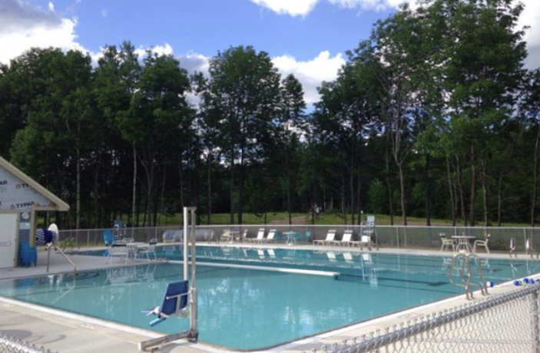
Samantha Wright Memorial Pool. An outdoor swimming pool was originally built in 1987, with a heating system added in 2001. The pool is located behind the town offices and adjacent to Riverside Park. In 2015, the town built a new $1.2 million state-of-the-art swimming pool (with $620,000 in In-kind donations of labor and materials) to replace the older pool. The updated pool was named in memory of Samantha Wright of Kingfield who served as the town’s pool director for a number of years and worked towards getting the new pool built. The L-shaped pool includes four, 25-yard-long lap lanes and a shallow section for beginners, a 40-inch handicap lift into the pool, and a bath house. The pool offers water aerobics classes and swim lessons. The pool is generally open from Memorial Day through Labor Day.

Outdoor Adventure Camp. The Carrabassett Valley Recreation Department hosts an Outdoor Adventure Camp at Riverside Park for 6 weeks in the summer for children ages 5-13. Camp activities include swimming, tennis, golf, wall climbing, water sports, cooperative and competitive field and ball games, arts and crafts, hiking and mountain biking, dramatics, and weekly themes such as environmental awareness, ecology, local heritage, nature, and weather.

Sugarloaf Regional Airport

The Sugarloaf Regional Airport is a public use airport owned by the Town of Carrabassett Valley. Located approximately one mile from the Valley Crossing / Town Office area, residents and visitors utilize the airport for private and commercial flights as well as recreational activities such as scenic flights and flight lessons.

COOPERATIVELY OWNED & MANAGED FACILITIES

The Anti-Gravity Complex

The Anti-Gravity Complex is a 21,000 square foot fitness facility located at the base of Sugarloaf, just off of Route 27. The facility was built in 2001 on land donated by Sugarloaf. The Complex has one of Maine’s largest indoor skate parks, two Olympic trampolines, an indoor rock-climbing wall, a multi-purpose court with a running track, and a fully equipped weight room, which encompasses the entire upstairs. The complex offers private trampoline and wall-climbing sessions as well as private skateboard lessons. The Complex is open year-round and attracts approximately 17,800 guests per year.

Carrabassett Valley Academy (CVA) had approached the town in 1999 to discuss building the Complex together. The Town eventually voted (80-20) to build the Complex and CVA and the Town split the funding. The Complex is operated through a joint partnership between the Town of Carrabassett Valley and CVA. The Town Recreation Director manages the facilities and organizes town programming for the Complex. An agreement is in place that allows the public to use the facility 65% of the time, while CVA uses it the other 35% of the time. Funding for operation of the Complex is similarly split as the Town contributes 65% of funds while CVA contributes the remaining 35%. Sugarloaf’s sales and marketing department also plays an important role by sending customers to the center as well as who work at the facility. A new ten-year operating agreement is currently being reviewed for approval in March of 2024.

CVA is looking to build and operate a separate adjacent facility to provide dedicated space for their training camps and weight training program. There is also interest in expanding the Complex to allow for pickle ball courts, however, space for expansion is limited due to the fact that the 5-acres of land available to the AGC Complex has a lot of wetlands which limit ease of further development.

PARTNERSHIP WITH SUGARLOAF

Sugarloaf Mountain

Sugarloaf is Maine’s second highest peak and the largest ski terrain area east of the Rockies, with trails and glades spread across Sugarloaf Mountain, Brackett Basin, and Burnt Mountain. Since its first trails were cut following World War II with the help of the Bigelow Boys and subsequently the Sugarloaf Ski Club, Sugarloaf has grown to become one of the nation’s premier winter resorts. From the 4,237-foot summit, skiers can descend 2,820 continuous vertical feet, the largest continuous vertical drop in the eastern United States. Sugarloaf’s 15 ski lifts can carry over 25,000 skiers every hour to the 1,360 acres of terrain on 179 trails. 46% of these trails are for expert skiers, 32% for intermediate skiers, and 22% for beginner skiers. Annual snowfall averages 135 inches with an average compacted snow depth on trails of 20 inches. Snowmaking covers 700 acres or around 50% of the terrain.

Sugarloaf has become more than just a place for skiing. It offers a complete year-round resort experience with lodging, restaurants, groceries, retail shopping, an art gallery, and health clubs all within walking distance of the ski slopes. It has convention and conference space available at the Sugarloaf Hotel and the Sugarloaf Inn, and these activities draw visitors throughout the year.

Boyne purchased Sugarloaf from Och-Ziff Capital Management in March 2018, along with sister resorts Sunday River and Loon, to gain full control of the mountain with the hopes of funding more on-mountain projects. Boyne’s plans for capital improvements include continued efforts to Mountain Operations thru updating and expanding snowmaking and thru updating chairlifts such as the Double Runner, Superquad, and Timberline Quad; continued developments in the West Mountain area; Bullwinkle's access road; and 9-hole golf course. A yurt at the top of Whiffletree was also proposed to provide on-mountain restrooms on the east side of the mountain. Sugarloaf unveiled its 2020 plan, and subsequently updated it to the 2030 plan, and it is expected they will continue to do so as goals are accomplished and new focuses are targeted.

The Town has had a unique and longstanding partnership with Sugarloaf. There is close and consistent communication between town management (e.g. Recreation Department, Select Board, Town Manager, etc.) and Sugarloaf departments (e.g. Skier Services, Golf Club, Outdoor Center, etc.). For example, the head of Skier Services attends Select Board meetings to discuss prospective projects, there is joint representation on the Golf Course’s Greens Committee, and similar joint involvement on some mountain bike trail development efforts.

Sugarloaf Golf Club

Completed in the fall of 1985 as a joint project between the Town of Carrabassett Valley and Sugarloaf Mountain, the Sugarloaf Golf Club has become known as a must-play in New England’s golfing circles. The course is 6,909 yards in length with a slope of 150 and has 18 holes. The greens have significant undulations with numerous shelves and the course’s signature holes—the 10th and 11th—offer stunning panoramic views of the Maine wilderness and feature dramatic drop offs from tee to green.

This prestigious par 72 course has been designated a “Best in State” golf course by Golf Digest magazine. The Club hosts several tournaments throughout the summer and fall seasons. A golf school offers packages that range from hourly lessons to week-long sessions and programs are offered to area school systems. The Town does not receive revenue from the course; however, residents are offered a lower rate.

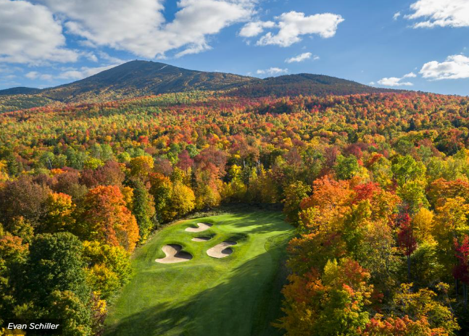
The Club is owned by the Town and leased to Sugarloaf and there is an option to renew the lease every ten years. The lease was renewed in 2023. The Town and Sugarloaf share equally costs of repairs and renovations.

The Greens’ Committee, which consists of the Town Manager, Recreation Director, club members, and Sugarloaf representatives, currently advises the Town Select Board and Sugarloaf with regard to operations, capital maintenance projects and further development of the golf course.

In 2003, the Town and Sugarloaf completed an $800,000 capital improvement project that included paving cart paths and the parking lot area, re-construction of the sand traps, and improvements to the driving range and drainage and irrigation systems. Under the terms of the lease renewal in 2000, Sugarloaf was responsible for the annual debt-service of this capital project. The 2000 lease agreement also enabled the town to purchase the golf course maintenance building from Sugarloaf and then lease it back to Sugarloaf. Vast improvements have been made to the course since 2003, including an extensive golf course irrigation project in 2012 and 2013. Significant flood related project improvements were also made to the course after Hurricane ‘Bob’ in 1987 and Tropical Storm ‘Irene’ in 2011.

Possible future plans for the course include remedying potential erosion issues on the famous 11th Tee, and major drainage renovations to the 4th and 7th fairways along with a couple of the greens. There are also discussions about building a 9-hole walking golf course, a trend among some major golf resorts in the county, that would take much less time to play, help improve traffic on the 18-hole course and add another recreational amenity along with providing significant revenue for the resort. The new course would necessitate an allocation of land from Sugarloaf and Town financing. A Town vote on this project may be possible as soon as Spring 2025.

Sugarloaf Outdoor Center

The Sugarloaf Outdoor Center is Maine's largest Nordic Ski center, featuring a newly renovated lodge and more than 60 kilometers of groomed cross-country skiing and snowshoeing, in addition to running, and winter biking. From mid-December to early-March, the Outdoor Center offers an NHL-sized skating rink and a full line of ice skate rentals for children and adults. The center is tucked away in the woods just minutes from the base area is Maine's largest Nordic center. The lodge hosts a full Nordic retail shop, rental center, and café. Trail fees and access to the lodge and ice rink are included in Sugarloaf alpine day lift tickets thru their Alpine Exchange Program. In the Summer and Fall, the Outdoor Center Lodge is occupied by a Bike shop that offers repair and rental services to support the mountain bike trail users.
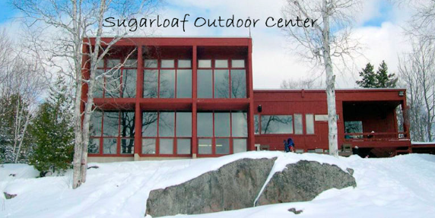
The Outdoor Center hosts races such as the Chenard Memorial Scholarship Race (the longest continuously run race in Maine) and the Inferno downhill Nordic race and offers guided day and evening snowshoe trips for adults and children.

The Outdoor Center building was built in 1977 and a significant renovation and expansion project was completed in 2008. The 2008 project also included building an updated 85’ x 200’skating rink, a new Nordic Ski stadium / training area, new larger septic system, and a 2.5-kilometer homologated Nordic Ski race loop. The town has a lease agreement with Sugarloaf to operate the lodge and Nordic Ski and snowshoe trails. The Town operates some Town programming at the Center including youth mountain bike camps in the summer. Carrabassett residents and property tax payers are afforded discounted rates for rental of the Center’s Lodge for Functions and some discount on seasonal trail passes.

MULTI-USE RECREATION TRAILS

TOWN-OWNED AND MANAGED TRAILS

Narrow Gauge Pathway

The Narrow-Gauge Pathway is a non-motorized, four-season, multi-use trail that follows the eastern banks of the scenic Carrabassett River, providing splendid views and picnicking along the way. Trail entrances are located at the Town Park, the Airport Trailhead, Campbell Field and the Stratton Brook Hut Trailhead. At approximately 6.6 miles long, the trail has a gentle grade that increases upstream from the Carrabassett Valley Town Office. In the winter, the trail is groomed for both classic and skate style cross-country skiing and is available for skiing, snowshoeing, walking and winter biking. A group of volunteers from the Carrabassett Region mountain bike club also groom adjacent single-track trails for winter fat tire biking.

The Narrow-Gauge Pathway also serves as an extension of the Maine Huts & Trails (MH&T) system connecting the Poplar Stream and Stratton Brook Huts in Carrabassett Valley. There is also a trail connection between the Outdoor Center and the Narrow Gauge.

While it was a rough unmaintained trail in 2000, the Narrow Gauge Pathway was significantly improved in 2003, with financial help from the State of Maine Department of Transportation. The original historic railroad tracks were laid in 1894 to transport timber, passengers, and freight. The portion utilized by the Narrow Gauge Pathway was abandoned in 1927. Part of the land is owned by Penobscot Indian Nation and part is owned by Sugarloaf. The Town voted in 2001 to improve the railbed into an improved non-motorized trail but thru considerable discussion decided to keep the pathway unpaved and the Town has a deeded easement with the Penobscot Indian Nation (first obtained from Dead River Company) to keep the trail as a non-motorized recreational pathway. The improved recreational trail extended from the Town Office, up Huston Brook Road, across Huston Brook, up the old Railbed for about 4 miles and then crossed the Carrabassett River to the newly created trailhead parking lot on Campbell Field Road.

Around 2007, with an easement from Sugarloaf, the improved trail along the old railbed was extended west to near Bigelow Station with a new bridge crossing the North Branch of the Carrabassett River and up to intersect with ME Route 16/27 and has since joined a side link to what is now the MH&T Stratton Brook Trailhead. The Town’s trailhead at Campbell Field interconnects to the extensive trail system located on the Town’s public lot (Outdoor Center) and Sugarloaf lands.

There have been four major floods over the last 12 years, two of which happened in 2023. These floods wiped out the original Campbell field bridge twice and in 2018 a substantial and well-designed new bridge was built. In 2011, the multi-purpose Munzer Recreational Bridge was constructed on the lower portion of the Narrow-Gauge Pathway which is accessed from the Airport trailhead. These bridges were built to accommodate trail grooming equipment and the Munzer Bridge was built to accommodate snowmobiles for access to nearby snowmobile trails. Land and Water Conservation Grant funds and some funding from the J.V. Wing Snowmobile Club helped fund the Munzer bridge. F.E.M.A. funding helped replace the heavily used Campbell Field bridge.

Public Town Lots

The ‘Town Public Lot’ consists of the Crockertown Lot (1,203 acres purchased in August of 2000, formerly called the “State Lot” and the Jerusalem Lot (930 acres, formerly called the “Town Lot”). Combined, the two original lots represent 2,133 contiguous acres. The Jerusalem Lot became a public asset of the Town when the Town incorporated in 1972. When the Town annexed the then Unorganized Territory of Crockertown in 1974 the State maintained ownership of the “State Lot” (Crockertown Lot) until the Town purchased the lot from the State in the year 2000. The “State Lot” contains deed restrictions that limit the amount of development to 25 contiguous acres (including the existing developed area). The lots are currently part of the Outdoor Center property and are being used for cross-country skiing, snowshoeing, mountain biking, hiking, and to some extent, hunting.

In 2020, the Town purchased the 222-acre “Jones Public Lot’ in the southern part of the Town. This lot is subject to a conservation easement for non-motorized trail use, forest management, trail use and conservation. Further development and management of this public lot is underway.

The Town’s Public Lot Forestry Committee provides management advice with the Town’s Forestry Management Consultant to ensure that forest management and timber harvesting on the Town’s public lots is sustainable. There are many options to consider such as recreational opportunities, watershed protection, wildlife management, sustainable forestry, fire risk management, and generating revenue.

Over the past twelve years an extensive mountain bike trail system has been built on the Outdoor Center Public lot. Additionally in more recent years, over fifty-five wooden trail bridges have been replaced with more substantial, permanent and less flood prone structural modular concrete panel bridges. Funding for this extensive investment has come from reinvestment of sustainable timber harvesting on the public lot.

TRAILS ON CONSERVED LAND

Bigelow Mountain Preserve Trails

Located in Western Maine, just east of the village of Stratton and 40 miles north of Farmington, Bigelow Preserve includes over 36,000 acres of public land. The preserve encompasses the entire Bigelow Range, which includes seven summits. Abutting the Bigelow Preserve, a small portion of public reserved land which belongs to Maine Bureau of Parks and Lands (MBPL) is located in Carrabassett Valley. There are 55 miles of snowmobile and ATV trails within the Bigelow Land Preserve. These trails are also part of "The Black Fly Loop," a vast network of 134 miles of trails considered to be the widest variety of riding in the East.

In the past, Penobscot Indian Nation has generously granted access to these trails from their lands in Carrabassett Valley on a year-to-year basis. In 2020, the Penobscot Indian Nation closed public access to the Bigelow Preserve trails via their land at both the Huston Brook Road and Carriage Road trail entrances. Town residents and visitors can still access the Bigelow trails by driving about an hour to alternative entrances outside of the Town.

While these trails are no longer accessible within the eastern half of Carrabassett Valley, the Town continues to financially assist the J.V. Wing Snowmobile Club in their maintenance of the Bigelow trails and Caribou Pond and Stratton Brook region trails through annual Town appropriations. The Club grooms the 10-foot-wide trails, carries out trail improvements throughout the year, and promotes safe snowmobiling in the area. Membership dues and all income from sled storage rental spaces also contribute to the club’s trail maintenance efforts.
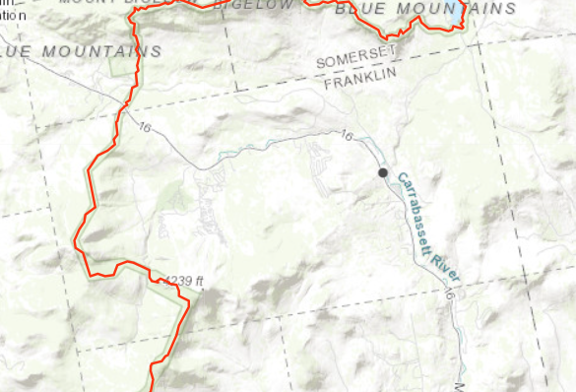
Appalachian Trail

Approximately 10 miles of the Appalachian Trail winds through the eastern region of the town of Carrabassett Valley, including the western slope of Sugarloaf Mountain and side trail to the second highest summit in Maine, North and South Crocker Mountains, and Stoney Brook Mountain. The Town occasionally collaborates with the Appalachian Mountain Club (AMC) and many local volunteers help to maintain the trails.
Map of the Appalachian Trail through Carrabassett Valley

OTHER POPULAR TRAILS

There are many other trails in the area. A couple of the popular trails include:

- Burnt Mountain Trail: a 2.5-mile hiking trail that can be used to access glades skiing in the winter.
- Maine Huts & Trails: a 35-mile network of well-built hiking and groomed cross-country skiing trails that connect overnight lodges huts with shared bunkrooms serve meals.

GENERAL TRAIL DEVELOPMENT AND MAINTENANCE

The development of interconnecting trails for biking, hiking, cross-country skiing, snowmobiling, and ATVing has been a long-standing goal of the community. In 2005-2007, the Town received grants to start a trail network and a Carrabassett Valley Region chapter of the New England Mountain Bike Association (CR-NEMBA) was started with lots of enthusiasm from local residents. There is a collaboration among the Town of Carrabassett Valley, Sugarloaf, CR-NEMBA, Maine Huts & Trails, and the Carrabassett Valley Trails Committee on general trail management, development, expansion, maintenance, and funding. They also collaborate with the State on State-owned land. The Town oversees general maintenance of the Narrow Gauge Pathway, and the Snowmobile and ATV clubs manage vegetation maintenance and water crossing improvements on their trail system respectively.

PUBLIC ACCESS TO WATER

Riverside Park

Riverside Park is an access point to several swimming holes in the Carrabassett River which runs parallel to the park.

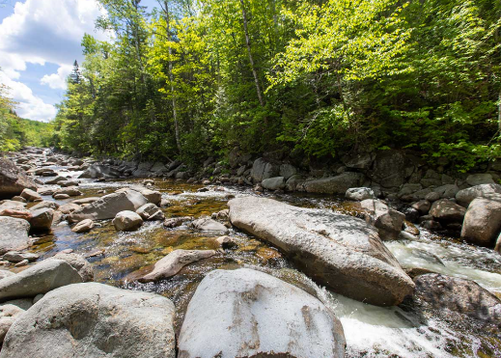
West Mountain Falls

West Mountain Falls is very popular trail and waterfall destination located upstream from the Sugarloaf Golf Club on the South Branch of the Carrabassett River. The entrance to the 0.5-mile trail leading to the Falls is on the left-hand side of the road when approaching the club’s parking lot. Several short paths disperse from the main trail towards the riverbank where there are many spots for exploring, picnicking, swimming, or wading.

Redington Pond

Redington Pond is located east of Sugarloaf Mountain with an area of 47 acres and a depth of 6 feet and the shoreline is undeveloped. Small inlets enter the pond from all sides and its outlet flows north into the Carrabassett River. Redington Pond and the property and surrounding it is owned by Penobscot Indian Nation. This property, including the trails, is closed to the public at the time of writing.

Flagstaff Lake

It had long been the goal of the Board of Selectmen to work with Penobscot Indian Nation and electricity utilities to create a direct access road to Flagstaff Lake across the Carriage Road in nearby Dead River Township. However, the road is now closed to public access. To access nearby Flagstaff Lake, there is a municipal boat launch in Eustis and a much longer drive to State of Maine maintained public boat landing at Long Falls Dam off the Long Falls Dam Road that Carrabassett Valley residents may use to launch boats including kayaks and canoes and to go swimming. With the new closure of Carriage Road, the public access off the Long Falls Dam Road takes nearly an hour to reach this water access point.

LOCAL & REGIONAL RECREATION ORGANIZATIONS

The Town of Carrabassett Valley collaborates with the following local recreation organizations:

Carrabassett Region New England Mountain Biking Association (CR-NEMBA): CR-NEMBA is a non-profit organization dedicated to the building and maintenance of a sustainable mountain bike trail network in Carrabassett Valley and surrounding areas. The group also promotes the use of its trails and strives to cultivate an inclusive mountain bike community in the area. They work closely with land managers and stakeholder organizations to gain and preserve access to the trails they build and maintain.

Carrabassett Valley Outdoor Association (CVOA): CVOA started out as a litter patrol. Today, with more than 500 members, CVOA is recognized as a leader for its dedicated efforts to protect outdoor heritage, create recreational opportunities, and organize outdoor activities. Activities include an annual ski trip out west and other distant resorts, camping outings to Baxter, Acadia and a coastal island, fishing trips, day hikes, waterfall tours, canoe trips, moonlight snowshoe hikes, and dinner dances. They also maintain one of the best pistol and shooting ranges in the State, stock a trout pond for catch and release fishing, and perform maintenance on the Appalachian Trail and other hiking trails.

Maine Outing Club: The Maine Outing Club is one of the largest student organizations at the University of Maine. The group organizes outdoor adventures from hiking and canoeing to rock climbing and skiing. Members actively maintain an 11-mile section of the Application trail in northern Maine, and own a rustic cabin behind Hugs Restaurant at the base of Sugarloaf for member access on land leased by the Town.

Maine Huts & Trails: Maine Huts offers over 80 miles of free, year-round, multi-use trails in the Northwestern Maine mountains. Thanks to generous land owners and donors, Maine Huts continues to ensure public access to remote and special places to all for generations to come. In the winter, the trails provide a curated backcountry experience for skiers, snowshoers, and fat bikers. In the summer, the trail network expands to welcome hikers, mountain bikers, and trail runners. Maine Hut Trails connect to the Appalachian Trail, Bigelow Range, miles of mountain biking trails, and more.

Carrabassett Valley ATV Club: The Carrabassett Valley ATV Club was formed in 2010 to pick up maintenance and development for a 21-mile network of trails that was previously maintained by clubs in Kingfield and Stratton. Since that time the club has grown to as many as 50 members and the trail network has expanded to 25 miles. The Club also works closely with the J.V. Wing Snowmobile Club with whom it shares a number of trails. Using membership funds and state, county and local grants, the club has undertaken annual trail improvement programs with a combined total of nearly $60,000 involving a thousand or more volunteer manpower hours. The network continues to join ATV club trails north and south of Carrabassett Valley and is a vital link in the 139-mile Moose Loop connecting seven ATV clubs in northern Franklin County.

JV Wing Snowmobile Club: Formed in 1987, the JV Wing Snowmobile club maintains over 55 miles of trails in the Carrabassett Valley area, including trails on and around Sugarloaf Ski Resort and the Bigelow and Popular Mountain ranges, and the Black Fly Loop. The Club grooms the trails with a BR-400 Bombardier snowcat and a PistenBully Trail groomer and continuously works on trail improvements throughout the year. The Club is 100% affiliated with the Maine Snowmobile Association.

Sugarloaf Ski Club: The Sugarloaf Ski Club has been an integral part of Sugarloaf Mountain since cutting the first trail on the mountain back in 1950. After more than 70 years, the club is still a vibrant and active member of the Sugarloaf community. The mission of the Club is to provide the opportunity for all youth to participate and excel in skiing and snowboarding, promote community building events, support competition, and preserve the history and heritage of the mountain.

SUSTAINABILITY & CLIMATE CHANGE

Maine’s statewide mean annual temperature has increased by 3°F since 1895, far outpacing the global average of 1.5°F. Maine’s seasonal average temperatures are projected to rise 10-13°F in winter and 7-13°F in summer by late-century. Extreme heat days over 90°F are expected to be two to four times more frequent by 2050.

Maine’s annual precipitation has increased more than 6 inches since 1895, and extreme precipitation events (1 to 4 inches of rain or more) are becoming more frequent. Climate models predict that the Northeast will see a 20 to 30 percent increase in winter precipitation, with less precipitation falling as snow and more as rain.

Winter Snowpack. As temperatures continue to rise and weather is becoming less predictable, it is becoming more difficult for resorts such as Sugarloaf to provide a consistent and reliable snow cover for their clientele. Warming temperatures are leading to more rainfall, less snowfall, melting snowpack, and changes in snow consistency on Sugarloaf Mountain as well the wide network of snowshoe, winter biking, snowmobile, and cross-country trails in the area. While a warming climate makes ski resorts more dependent on snow making, snowmaking also depends on temperatures staying below 28 degrees F.

Increasing dependence on snowmaking will compel higher expenditures. Meanwhile, the unpredictability of snowfall will also obscure efforts to plan and invest in the infrastructure needed to run the resort and facilities. Making matters worse, a shortened ski season will lead to a further reduction in revenue. Models predict that by the year 2080, the ski season in Maine will be shortened by one month (under a high emissions scenario) or by two weeks (under a low emissions scenario).

Summer Rainfall. The drastic increase in rainfall also impacted Riverside Park which lost three weeks of pool use out of its short 12-week operation schedule in 2023. The persistence of rainy days meant fewer visitors came to enjoy the golf course and hiking and mountain biking trails. The decrease in tourism affected the local economy, with observably reduced patronage at restaurants.

Flooding. Flooding is becoming a major problem in Carrabassett Valley. In the past twelve years, the Town has experienced four floods, two of which have that cut off access to Route 27 for more than a day without heavy earthwork and caused millions of dollars in damages. Most Recently, in May and 2023 heavy rainfall caused flooding along the Narrow Gauge Pathway, causing damage including eroding riprap and parts of the trail. These floods also squandered a summer of trail building.

Heatwaves / Drought. Rising temperatures also have an impact on summer activities such as swimming, hiking, biking, golfing, and outdoor camp activities. Higher temperatures can cause dehydration and heat stroke and are particularly dangerous for younger and older populations, not to mention pets. While rainfall is a major challenge, periods of drought are also becoming more frequent. The region experienced a drought during the summer of 2022.

Infrastructure. The increased frequency and intensity of extreme weather events (downpours, floods, heat waves, drought, and high winds) will also decrease the functionality and resiliency of made-made infrastructure such as trails, roads, bridges, culverts, chairlifts, and recreation facilities.

Natural Habitats. Climate changes and extreme weather also reduces the resiliency of the fragile natural habitats and ecosystems that surround and support recreational activities in Carrabassett Valley. Changes in temperature, precipitation, and snow cover affect wildlife and plant life, which can have a ripple effect on the entire ecosystem. For instance, increased rainfall is causing trees in the area to uproot and fall, making activities such as hiking, biking, ATVing, snowmobiling, and alpine and cross-country skiing more hazardous. Fallen trees can obstruct trails and lead to further soil disturbance and potentially erosion, and thus and an increased need for added trail maintenance.

Climate Migration. Warmer temperatures and other climate impacts are impelling people to move north to places like Maine, Vermont, and New Hampshire. As the local population in Carrabassett Valley inevitably grows in terms of both residents and visitors, there will be growing pressures on recreation facilities, services, roads, and the natural environment that supports these activities. A growing population and demand on resources will likely increase home values and general living costs as well. It also creates an opportunity for the Town to increase economic revenue and to improve and expand its offerings.

Economic & Administrative Pressures. All of these growing environmental threats are not only putting pressure on the local economy but they will need to be considered in future planning for the repair, fortification, construction, and management of recreation trails, facilities, and services.

CONSERVED LAND

The Town of Carrabassett Valley is home to approximately 13,500 acres of conserved land, located mostly in the western region of the town, and in the center of town. The Penobscot Indian Nation also owns 24,000 acres of land, nearly one one-half of the total 54,000-acre land base in the town. Their lands are predominately undeveloped and primarily managed for timber harvesting.

Municipal Land. The Town of Carrabassett Valley owns 2,105 acres of conserved public land in the center of town and 220 acres of land along the Carrabassett River in the eastern side of Town.

State Land. The Maine Bureau of Parks and Lands owns and manages 399 acres of Public Reserved land in the north of town abutting the Bigelow Preserve known as the Height of Land Farm block. They also manage 9,000 acres of conserved public land in the western mountain region of town (the Crocker Mountain Unit). The Trust for Public Land facilitated the acquisition of the Crocker Mountain Unit in 2013, by securing the opportunity to acquire the property and leading the effort to raise the acquisition funds. Additional funding came from the Land for Maine’s Future ($650,000), Town of Carrabassett Valley and over 100 private donors, including the Open Spaces Institute’s Transborder Land Protection Fund.

Federal Land. The US National Park Service owns 1,693 acres of conserved land within the Appalachian Trail Corridor.

Penobscot Indian Nation Land: The Penobscot Indian Nation owns 24,000 acres, almost one-half of the total land base in the town. The Penobscot Indian Nation’s land was transferred to them as “Fee Land” from Dead River Co. in 1980. Their land is largely undisturbed other than some forest management efforts and development of a few out-parcels for residential dwellings.

Conserved Lands and Undeveloped Habitat Blocks & Connectors in Carrabassett Valley
(Public lot should all be yellow but can this be done from the state mapping source? Also, should the narrow gauge pathway show as a mapped public easement? Also add 220 ac Jones Parcel?)
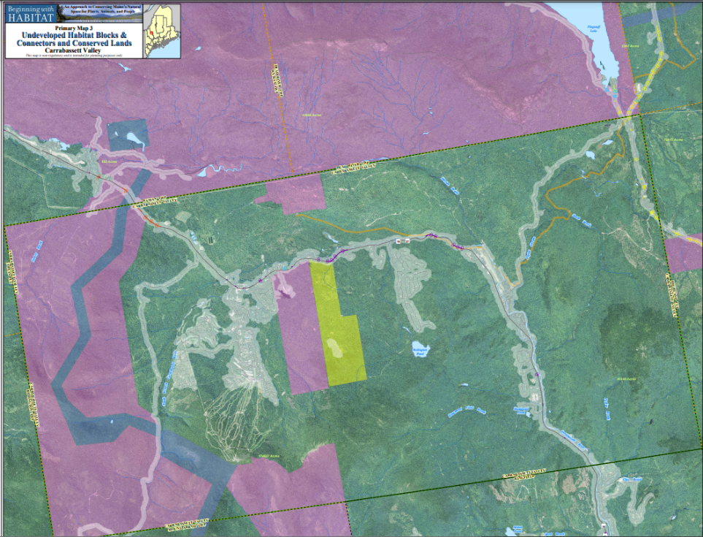

Town-owned and Penobscot-owned Land in Carrabassett Valley
(Same as facility section – misleading as not all the gray land is town?)

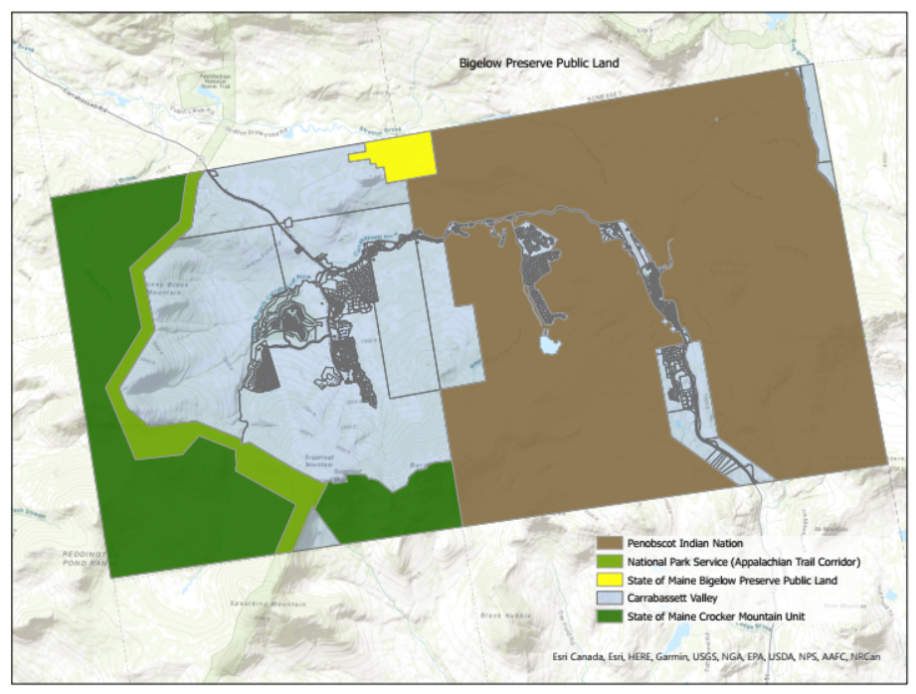

Maine Climate Office. (2023) “Climate Change in Maine.”
Union of Concerned Scientists. (2007). Confronting Climate in the Northeast: Science, Impacts, and Solutions.
Maine Climate Office. (2023) “Climate Change in Maine.”
Union of Concerned Scientists. (2007). Confronting Climate in the Northeast: Science, Impacts, and Solutions.

