PUBLIC FACILITIES & SERVICES

Carrabassett Valley provides a range of public facilities and services designed to enhance the quality of life for residents and visitors alike. This chapter describes existing public facilities and services, and the extent to which they adequately meet the Town’s needs today and over the next ten years. The goal of this chapter is to plan, finance, and maintain an efficient system of public facilities and services that will accommodate the Town’s future needs.

KEY FINDINGS

- Carrabassett Valley provides a range of public facilities and services designed to enhance the quality of life for residents and visitors alike.
- Carrabassett Valley operates under a Town Meeting form of government with a 5-member Board of Selectmen, a Town Manager, and several service-based committees.
- Emergency services include police, fire, EMT, and Life Flight services as well as mutual aid agreements with neighboring towns for additional support.
- The Police Department collaborates with Sugarloaf in providing security services and police protection for the town and mountain and emergency services.
- Residents and visitors utilize health services at Franklin Memorial Hospital in Farmington and regional health centers in Kingfield.
- The Public Library serves as an important cultural center and community gathering space.
- Rather than operating its own public school system, the Town provides tuition for students to attend Carrabassett Valley Academy and schools in neighboring towns.
- The Carrabassett Valley Sanitary District (CVSD)’s 100% chemical free sewage treatment system has a high capacity that could potentially double over time.
- The Town is exploring solar power options for its municipal buildings and adding EV charging stations in the community.

RECOMMENDATIONS FROM 2003 COMP PLAN

Utilities and Communications

- Off-mountain, there is a plentiful supply of groundwater that should be capable of meeting the Town's foreseeable needs. It is the policy of the Town to protect this groundwater supply—both the aquifers and the adjacent recharge areas (See Natural Resources policies)—and to avoid having to construct expensive centralized water supply systems.
- The Town should develop wellhead protection measures to protect the groundwater quality in the immediate vicinity of all wells serving public and “community” water systems as defined by state law and incorporate these provisions into the Zoning Ordinance and Subdivision Ordinance. These wells include those serving municipal facilities such as the Outdoor Recreation Center and Town Office, wells providing water supply for the Sugarloaf system, and wells for private uses such as the academy.
- The Town supports the concept of renovating the former dam at Caribou Pond sometime in the future both as a plentiful source of water for domestic, fire protection and commercial needs, and as a way to regulate flows on the Carrabassett River.
- The Town, in conjunction with the Carrabassett Valley Sanitary District, should update the sewerage needs and feasibility study for the Carrabassett Village, Sugarloaf Village, Poplar Stream, and Spring Farm areas. The purposes of the study should be to:
- Re-evaluate the need for alternative sewage disposal systems including the extension of public sewerage to serve these areas given current costs, the current and anticipated future pattern and intensity of use, and emerging technology;
- If there is a need for a sewage disposal alternative in any of the areas determine the most cost-effective solution to meet the need;
- Establish an equitable system of financing construction of such a facility if needed; and
- If the study confirms that the aquifer is both a critical water supply source and susceptible to growth pressures, but that there is no economically acceptable alternative to individual on-site waste disposal, re-evaluate the need for the Town's zoning to further limit future development and conversions in the area to a level recommended by the engineering study.
- High density development should be limited to areas with centralized sewerage, as indicated on the Future Land Use Map.
- The Town should continue to work with the Carrabassett Valley Sanitary District to develop an alternative method for accepting septic tank sludge into the sewage treatment system.
- The Town should work with the telephone companies and cable and satellite TV providers to assure that Town residents and businesses have affordable access to state-of-the-art communication services including high speed Internet access.

Health Care

- The Town continues to support the presence of a seasonal health care clinic/free-standing emergency room on the mountain to serve both visitors and residents of Carrabassett Valley, as a supplement to the private physicians' practices in surrounding communities and the hospital services in Farmington and Skowhegan.
- In the development of a Town Center and, in particular, of a multipurpose facility in the Town Center, space for a health care clinic/free-standing emergency room should be considered.
- The Town should support, where feasible, the provision of additional local health care services such as dental, optical, and related health services.

Finance and Administration

- The Town should continue its current practice of capital improvements programming, using five-year periods, in which a capital improvements budget is adopted annually. The recommendations of the updated Facilities Plan should be incorporated into the Capital Improvements Plan.

Public Facilities

- The Municipal Building and related storage building should remain at their present location and be upgraded and expanded, as needed, in accordance with the Facilities Plan.
- The Town should continue to monitor the need for a public safety building and conduct a feasibility study for the construction of such a facility. If a public safety building is constructed, it should be located in the general area from the Touring Center to the base of Bigelow Hill.
- The Town should continue to invest in the maintenance and upgrading of the Transfer Station and investigate alternatives for the disposal of brush, wood, and inert materials.
- The Town should develop strategies and incentives to increase the level of recycling done by residents and businesses.
- The Town should develop an updated Master Plan for the airport.
- The Town should develop a plan for future use of the “information center” building including its possible use as the library, as a modest arrivals building for the airport, as a public rest room facility, as well as a continuation of its use as the Ski Museum of Maine as proposed in the Facilities Study.
- The Town, in conjunction with the Library Board, should explore the long term development of a new library facility, possibly in conjunction with the Ski Museum of Maine, to meet the needs of the community.

Fire Protection

- The Town should evaluate the facilities of the Fire Department as recommended in the updated Facilities Plan.

Schools

- The Town should continue to monitor the SAD #58 contract, and based upon the results of the current School Study, continue to explore the feasibility of building a school in Carrabassett Valley.

Hazard Mitigation

- The Town should continue to limit development in mapped flood plains that are currently undeveloped to minimize potential damage and reduce the risk from flooding.
- The Town should maintain a coordinated emergency response plan to address emergency situations including natural disasters, hazardous spills, and major fires on the mountain. This plan should be coordinated with County emergency preparedness officials, the county sheriff, and Sugarloaf Mountain Corporation.

OVERVIEW

Municipal services include town administration, emergency services (fire, police, EMT, and LifeFlight), waste management, parks and recreation, and the public library. The Sugarloaf Water Association (SWA) provides public water services and the Carrabassett Valley Sanitary District (CVSD) provides waste water and sewage treatment services. The Recreation Department oversees the management and operations of facilities at the Town Park, Narrow Gauge pathway trail, and the public library serves as an important cultural center and community gathering space. While there isn’t a local public school system, the Town offers financial support for students to attend Carrabassett Valley Academy and schools in surrounding towns.

General municipal administration employs nine full-time year-round employees. The town does not have a Public Works Department as the Town contracts out to local contractors as needed. Since there are very few town roads, there are several road associations and home-owner associations that take care of road maintenance.

ADMINISTRATION

Carrabassett Valley has a Town Meeting form of government, which is administered by a 5-member Select Board and a Town Manager responsible to the Board. The Town Manager is also the road commissioner. Paid staff consists of a Town Manager, Town Clerk / Tax Collector, Treasurer / Secretary, Code Enforcement Officer/Local Plumbing Inspector, Fire Chief / Emergency Management Agency Director, Police Chief, Recreation Director, Assistant Recreation Director, Librarian, and part-time Airport Manager. The tax assessor is currently contracted out.

Permanent committees appointed by the Selectmen include:

- Airport Advisory Committee
- Board of Assessment Review
- Budget Committee
- Comprehensive Plan Committee*
- Greens Committee
- History Committee*
- Planning Board
- Public Lot Forestry Committee*
- Recreation Committee*
- School Committee

Committees elected by residents:
- Sanitary District Trustees
- Zoning Board of Appeals

*Committees formed since the 2003 Comprehensive Plan

Recreation Department

The Town’s Recreation Department is staffed by a Recreation Director, Recreation Assistant / Park Maintenance / Program Coordinator, Mountain Bike Trail Construction / Trail Boss, Day Camp Director, Pool Director and staff, supervisors for tennis and the climbing wall, and instructors for pickleball and the skate park and trampoline.

The Recreation Committee advises the Town on utilizing the Recreation Reserve Fund and developing local recreation programs. The Committee oversaw the development of the Town Park and was instrumental in the improvements to the Narrow Gauge pathway trail. The Committee also oversees all of the recreation programs sponsored by the Town. The work of the dissolved Conservation Commission is now performed by the Recreation Committee.

As might be expected in a community that derives its livelihood from recreation, residents have recreation resources available to them that go far beyond what most communities can offer. These facilities are a mix of “destination” facilities (the golf course, touring center, ski area, etc.) and the local facilities (the Town Park). Trying to sort out local versus visitors’ needs and desires makes recreation planning more complicated. There are three levels of potential need or demand: local residents, regional residents or day-trippers, and destination-based visitors.

The town endeavors to support facilities and services used by local residents (e.g. the Town Park) while destination facilities used by visitors (e.g. the golf course) are more likely to charge for participation. In some cases, charges for facilities and services vary for residents and nonresidents.

MUNICIPAL FACILITIES

Municipal Building:
Built in phases from 1978 to 1985, the 5,860 square feet Municipal Building houses the Town Office, the Village Fire Station, and rental space for the Ambulance Service. The Town Office includes a meeting room and a storage room and hosts the town manager, clerk and treasurer, code enforcement officer, and assessor. Adjacent to the Town Office is Riverside Town Park with public tennis courts, basketball courts, playground and seasonal swimming pool. The Town Office has served the Town well, but there has been discussion about an expansion or renovation to improve working spaces, storage of hardcopy records, improve lunchroom facilities, and still offer meeting space that also doubles as the control center when the Summer Camp is operating from early July thru August.

Municipal Storage Building: This is a 22’ x 56’ building adjacent to the municipal building and in close proximity to the Carrabassett River. There are five storage bays and summer camp daily operations office in the building. Three of the bays are used for summer camp equipment, with some pool storage, one of the bays is used by the general town and ambulance service storage and one is used for park/recreation equipment. An additional garage was built in late 2019 for the Recreation Department to store and protect their programming materials such as bicycles, kayaks, and transport trailer, and also the ability to store additional seasonal pool furniture.

Post Office: Carrabassett Valley does not have a United States Post Office. However, there is a permanent US Post Office mailbox outside of Ayotte's Country Store at 1215 Carrabassett Drive and the grocery store sells stamps. There are also several unofficial but recognized UPS drop-off locations. The closest US Post Office is in neighboring Kingfield, a 15-minute drive from the Carrabassett Valley Town Office. There is a shortage of post office boxes for Carrabassett Valley residents. The Town would like to grow the mail service and enable residents in the condos on the mountain to access mail, especially as guests and residents are residing here for longer than just over-weekend stays.

EMERGENCY SERVICES

Fire Protection Services

Carrabassett Valley is protected by a paid call fire department with sophisticated equipment. A full time Fire Chief heads the department. Approximately 20 year-round citizen firefighters fill out the department, and in the winter season another half-dozen seasonal residents. Due to staffing shortages, the Fire Department added a per diem firefighter who works a 12-hour day shift every Saturday and Sunday throughout the year. During the ski season, the department is staffed with two firefighters at night and the Fire Chief covers Monday thru Friday days as well. Additional protection is provided through mutual aid agreements with both Eustis and Kingfield.

The fire department provides a full range of services, including fire suppression, extraction, back-country rescue, and public education. The fire department is a Licensed EMS First Responder Service with EMTs, Additional education programs are available to Sugarloaf Mountain Corporation employees. Between 2018 and 2022, the Fire Department responded to an average of 72 calls per year. Northstar, a Maine Health Owned Company, provides ambulance service and a paid paramedic staff is on call 24 hours a day.
The Department operates a 100-foot Aerial ladder with pump and water, Dodge Ram Quad Cab pickup truck, fire pumper-tanker (2000 gallon), a Ford mini pumper truck (new in 2023), a Rescue pumper truck, Jeep trailer (for hauling snowmobiles, etc.), Arctic Cat snowmobile, all terrain ATC vehicle, and a Yamaha snowmobile. The Department has an equipment replacement plan to upgrade its equipment as the equipment’s useable life diminishes.

Figure 1. Carrabassett Valley Emergency Calls (2019 – 2023)
Type of Call | 2023 | 2022 | 2021 | 2020 | 2019
Car Accidents | 8 | 7 | 8 | 4 | 11
Vehicle Fires | 1 | 2 | 1 |  | 2
Smoke Investigation | 10 | 8 | 5 | 2 | 4
Electrical Fires | 2 | 1
Odor Investigation | 7 | 2 | 3 | 1
Water Flow Sprinklers | 1 | 4 | 1 | 2 | 2
Chimney Fires | 2
Dumpster Fires | 2 | 3 | 2 | 3 | 3
Structure Fires | 1 | 1 | 1
Fuel Spills |  |  | 1 | 2
LP Gas | 18 | 12 | 17 | 14 | 20
Out of Control Permit Burns |  |  |  | 2 | 2
Downed Power Lines | 3 | 4 | 2 | 4 | 4
Carbon Monoxide Calls | 6 | 4 | 6 | 3 | 7
Fire Alarms | 11 | 6 | 2 | 4 | 5
Mutual Aid | 5 | 4 | 6 | 4 | 6
Snowmobile Accident |  |  |  | 1 | 1
Search & Rescue | 2 | 4 | 1 | 2 | 2
Traffic Detail | 4 | 3 | 2 |  | 7
Life Flight Standby | 4 | 3 |  | 1 | 1
Storm & Wind Damage | 2
Forest Fires
Plane Crash
Lift Accident
EMS First Response | 12 | 5 | 7 | 3 | 9
Totals | 101 | 73 | 65 | 52 | 86

Fire Stations

Village Fire Station. The Village Fire Station is a three-bay, 40 x 40 foot, 1,600 square-foot garage located at Valley Crossing, adjacent to the Town Hall and Park. This facility houses our Pumper/tanker and Ram Utility Pickup. Northstar has two ambulances and living quarter in this same building.

Mountain Fire Station. The Mountain Fire Station is a 7000 square foot facility located on the Sugarloaf Access Road. The station was built in 2020 on a two-acre parcel of land donated by Sugarloaf. The living quarters in this station are occupied from 6:00 PM to 6:00 AM on weekends, holidays, and vacations during the winter season. The five bays house our Ladder Truck, Rescue Pumper, Mini Pumper and five trailers that carry snowmobiles, utv, forest fire tools and traffic control equipment. Other features of the new station include crew living quarters, decon room, and work out/ exercise area. This is a significant upgrade from the Mountain facility that was occupied as noted in the 2003 Comprehensive Plan and will serve the community well far into the future. This newer facility at times has and will continue to serve as a regional outpost to local and state agencies during backcountry search and rescue efforts and during other rescue efforts on local trails and in the surrounding wilderness.

Fire Department Training Building. The Fire Department Training Building, located on Town land donated by the CV Sanitary District Land, is three-stories high, with two large metal (container) wings. Its purpose is to allow training for large structure fires (hotel, condominium, etc.).

Police Services
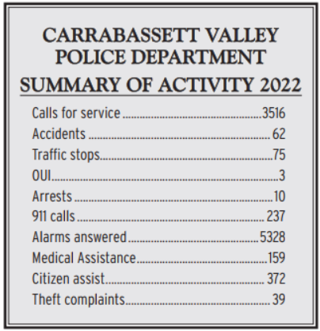
The Police Department provides town-wide police protection to all residents and visitors in the Valley. Additionally, through a unique partnership with Sugarloaf, the Police Department also provides security services for Sugarloaf Mountain.

The Police Chief is the only employee of the Town while all of the security personnel working for the Chief are employees of Sugarloaf’s Security Department. The entire operation provides police protection for the town and security for Sugarloaf as well as many mountainside and other private properties.

Carrabassett Valley remains one of the safest communities in the state. In the 2022 Town Report, the police Chief reported while the number of accidents (62), arrests (10), and reports of theft (39) decreased, calls for service rose (3,516) as did alarm calls (5,328). The department responded to 9 injury-based accidents and 3 commercial truck accidents.
Figure 2. Carrabassett Valley Police Department Activities (2022)

The Police Department operates a GMC Terrain police car, Ford F150 truck, Ford police interceptor, Suzuki ATV, and an electronic solar-based sign used for occasional traffic issues, events, etc.

Police Station/Security Office

The CV Police Station and Sugarloaf Security is located at 9000 Main Street Village West on Sugarloaf Mountain near the SuperQuad. Since 2003, the Town expanded the police station area, adding more storage and alarm technician space provided by Sugarloaf. There have been considerations to relocate the dispatch center to a less congested space, but at this time it serves the Town and the resort well in its current location.

Ambulance & LifeFlight Services

The NorthStar ambulance service, operated by the Franklin Memorial Hospital in Farmington, serves the Town of Carrabassett Valley. NorthStar has been operating for 15 years, serving 23 communities. Ambulances deliver patients to both Franklin Memorial Hospital and Redington-Fairview General Hospital in Skowhegan. There are usually 1-2 ambulances based at the Town Office. Life Flight of Maine, operating out of the Town Airport, is another important emergency service available to the town. The Sugarloaf Regional Airport maintains an Automated Weather Observing System (AWOS) weather station and supports a secure and safely maintained landing site for LifeFlight of Maine to land and transport critically injured residents and visitors from Western Maine, serving Carrabassett Valley all the way to the Canadian Border and neighboring rural backlands.

Sugarloaf Emergency Services

Sugarloaf has a ski patrol and first aid station. There is no longer a separate ambulance service or clinic operating at Sugarloaf. The Sugarloaf Ski Patrol is well served by the local ambulances and paramedics. Individuals with serious injuries are sent to Franklin Memorial in Farmington and Redington-Fairview General Hospital in Skowhegan.
HEALTH CARE

For a relatively remote community, Carrabassett Valley has a sophisticated network of traditional health care services not too far removed. The cornerstone of the region’s health care network is Franklin Memorial Hospital (FMH), which is located in Farmington, 30 miles to the south of Carrabassett Valley. FMH is a nonprofit community hospital that provides general and specialized services to residents across the region.

Complementing this acute care service is the Mount Abram Regional Health Center, a family practice in Kingfield that offers traditional patient care. Services include acute and chronic illness support, psychiatric care, counselling, pediatric care, and lab services.

WATER UTILITY

Sugarloaf Mountain Corporation’s Water Department began operation in 1955. The Department operated and maintained two drilled wells to provide potable water to ski operations and services in the Base Lodge area. For thirty-seven years the water department struggled to meet the challenges of building a public water system on the face of a mountain that was continually and sometimes rapidly being developed into the Sugarloaf ski resort.

The Sugarloaf Water Association (SWA), was formed as a privately owned, non-profit organization in 1992 to more effectively meet the future water demands of the developing area. While a portion of Carrabassett Valley residents rely on a combination of private wells and small shared-group wells, the SWA provides adequate and safe potable water and readily available fire protection to around 1300 private residences (homes and condominiums), a hotel, restaurants, and other resort facilities on the mountain. The SWA service area is shown on the map below.

SWA’s public water system includes eight drilled wells and pump stations, one filtration plant, two reservoirs, two treatment stations, one lab, seven pressure reducing stations, two transfer pump station, 23 miles of water mains of water main, 744 potable water and fire service lines, and 82 fire hydrants. This water system serves the Sugarloaf Resort community, on average 142,000 gallons per day in the winter and 56,000 gallons per day in the summer. Finished water storage on the mountain is provided by two 350,000-gallon concrete water storage tanks located on the east and west sides of the mountain, with a third 300,000-gallon concrete water storage tank under construction above the Sugarloaf village. The water system contains seven pressure zones and seven pressure reducing stations (PRVs) that provide service to the west and east sides of the mountain.

SWA’s primary water source is a combination of seven deep bedrock wells located on Sugarloaf Mountain. Their secondary source is the South Branch Carrabassett River, filtered through a 325 gpm Kinetico Macrolite filter system located on West Mountain. The system relies predominately on the groundwater sources during the off peak (non-ski season) and supplements the groundwater sources with treated water supplied by the Carrabassett River during the ski season to meet higher water demands.

SWA injects two chemicals into the water: sodium hypochlorite “liquid chlorine” to protect against microbial contaminants and Aluminum Chlorohydrate as a coagulant in the filter process to remove turbidity and organics.

The entire water system’s security and operations is supported by a Supervisory Control and Data Acquisition (SCADA) system and surveillance cameras running over a private network. Additional security systems and surveillance is provided by Carrabassett Valley Police Department.

The water systems greatest challenges today are increasing organic matter in surface water source induced by climate change and man-made contaminate like Per- and Polyfluorinated Substances (PFAS) and deicing salts reaching groundwater sources. To aid with increased drinking water and snowmaking demand, SWA is working with Sugarloaf to build another pond reservoir.

WASTEWATER TREATMENT

The Carrabassett Valley Sanitary District (CVSD) is a Quazi-Municipal Entity, formed under Title 38, Chapter 11 of the Maine Revised Statues in 1993, that operates the district’s sewage treatment facility and sewage collection system. The CVSD lays, repairs, and maintains pipes, drains, sewers and conduits in, along and through any public or private ways and public grounds and collects, purifies, distributes, and disposes of sewage, commercial and industrial waste. The CVSD also operates automated spray irrigation and snowmaking systems.

As of January 1, 2023, the District services 1,383 properties and 33 commercial establishments. There are 83 approved but undeveloped residential sites, only five of which are developer-owned. The Sanitary District has high capacity that could potentially be doubled over time.

Sewage Collection System. Collected sewage flows by gravity through a system consisting of 20 miles of sewer main ranging from 6 to 16 inches in diameter and approximately 300 manhole structures. All collected sewage is pumped, via a force main, to the district’s treatment facility. The sewage pumping station is fitted with a back-up generator for uninterrupted service if public utility power is lost.

Sewage Treatment Facility. This is 100% chemical free treatment system; no insecticides, herbicides, algaecides nor disinfection chemicals are used. The sewage treatment facility consists of one aerated lagoon, three primary storage lagoons and three backup storage lagoons. Each backup storage lagoon is designed to hold 5.8 million gallons, giving a total lagoon volume of 38 million gallons of which 33 million gallons is storage.

The Maine Department of Environmental Protection selected CVSD to be part of a study to determine the extent of PFAS contamination in the State. At this time, there are currently no federal drinking water quality standards (Maximum Contaminant Level or MCL) for any chemical in the PFAS family. In June 2022, EPA announced new health advisory levels for four PFAS compounds that set the health advisory levels to near zero and below the level that EPA’s able to detect the compounds. The sampling program at CVSD will likely help define background levels of PFAS, possibly from air deposition. Also, given the Town’s lack of industrial businesses, it should be a good indication that PFAS is entering the wastewater system from consumer products.

Effluent Disposal Systems and Licensed Volume. Treated effluent is pumped to a land-based disposal systems comprised of a forested irrigation system and a freeze nucleation (snowmaking) system. The spray irrigation system is designed to dispose of 44 million gallons of water annually. The snowmaking system is sized to dispose of 54 million gallons of effluent water annually.

Permissions and Land Leases. The district currently has “trial use” permissions with the Carrabassett Valley ATV Club, J.V. Wing Snowmobile Club, Maine Huts and Trails, and CRNEMBA, as well as land leases with the CVOA Shooting Range and Maine Huts and Trails Stratton Brook Hut and Carrabassett Solar 1, a private solar farm which occupies approximately 40 acres of CVSD’s property and went online in 2023.

WASTE MANAGEMENT

The town’s Transfer Station, located on top of Bigelow Hill, was built in 1985. The Transfer Station’s three compactors were renovated in 2002-2003. Approximately 1,130 tons of waste were created from dwellings and businesses in Carrabassett Valley in 2023, including 66 tons of recycling. The Sugarloaf base lodge, hotel, and condos made up 57% (618 tons) of the total solid waste stream.

The amount of solid waste generated in the community has changed over time. In 1984, between 350 and 550 tons of solid waste were generated each year. In 2002, this had increased to between 1,400 and 1,800. Despite an increase in residents and visitors in the area today, the waste stream has decreased to around 1,000 to 1,200 tons due to community efforts to improve the recycling program.

Recycling & Composting

The community recycles approximately 6% of the waste it generates. In 2023, the transfer station processed nearly 47 tons of recycling and Sugarloaf, which has a small recycling center on the mountain, sent 19 tons of recycling to EcoMaine. Old Corrugated Cardboard/ Containers (COO) makes up 65% of all recycled materials. The State gives the town recycling credits (for reporting purposes) for returned bottles and cans, and for the Town’s composting program.

The recycling building, built in in 2001 was originally used to sort materials before recycling was placed in metal dumpsters for bulky transport to processing as is now the practice. It is now a popular “take it or leave it” shop informally named the ‘Carrabassett Maul.’ The State of Maine has mandated separate disposal of discarded electronic equipment (TV’s, computers, etc.) and fixtures containing mercury for businesses and municipalities. When these products are brought to the attendant, they are housed in the secured Universal Waste Storgae Building until a hired contractor visits periodically to transport the materials to licensed processing facilities.

The Town, through its own funding and grants, built a small building in 2001 to house two “Earth Tubs,” a composting system that collects food waste from local restaurants. The town added a third Earth Tub in 2003-4. This facility is located on Sugarloaf land, near the Golf Course Maintenance Building. The Town has also been discussing the possibility of collecting compost from households or residents bringing compost to another central location.

POWER & TELECOMMUNICATIONS

Electricity Services. Central Maine Power (CMP) is the primary electricity provider in Carrabassett Valley. Most of the power comes from the Wyman dam in Moscow. A biomass plant in Eustis also provides electricity. Sugarloaf uses a significant amount of electricity for snowmaking. Sugarloaf Mountain Operations Staff have discussed usage and capacity with CMP as they make plans to increase snowmaking on the mountain. CMP indicates that they have capacity at the Bigelow Substation to meet the needs for the expanded snowmaking efforts as well as the current West Mountain Expansion of homes and condos.

Construction of Carrabassett Solar 1, a 6.76-megawatt solar farm commenced in 2021 and went online in late 2023. It occupies land leased from the Carrabassett Valley Sanitary District and is owned and operated by Novel Energy Solutions. The town is also interested in exploring mounting solar power on town buildings and facilities.

Internet Access. Spectrum has been the main internet service provider in town and is known to be studying possible upgrades to their facilities. Their service includes a relatively reliable fiber optic cable. There is a movement in Franklin County to improve broadband. TDS Telecom commenced installation of fiberoptic trunklines and some CV neighborhoods in late 2023 and it is expected that they will gain additional service neighborhoods in the coming years with their upgraded service. TDS backs up their network so that during an electrical power outage, service is still available on their system.

Cellular Coverage. Cellular coverage is strongest in the west part of town, up and around Sugarloaf Mountain and there is limited coverage in the southern/eastern part of the town. The town cannot allow a tall cellular communication tower near the airport due to height restrictions, but a lower height communication system is needed to serve the lower Valley region on the east side of Town.

EV Charging Stations. There are a total of 15 Electric Vehicle (EV) chargers in Carrabassett Valley. In 2022, Sugarloaf installed five SWTCH stations in parking lot E and four town-owned Level 2 SWTCH charging stations in the Golf Course Parking area. There are also two Tesla charging stations and two Level 1 stations located in the hotel guest parking lot. In late 2023, two Town-owned Level 2 ChargePoint stations also came online at the Outdoor Center.

Sugarloaf has plans to increase the EV infrastructure to accommodate the growing needs of their guests and the Town is interested in installing EV charges in other high use areas. Additionally, many of the local condo developments are seeking ways to maintain accessibility to the charging stations and adequate vehicle parking while managing restrictions for emergency and snow removal equipment.

SUGARLOAF REGIONAL AIRPORT

The Sugarloaf Regional Airport is a public use airport owned by the Town of Carrabassett Valley. Located approximately one mile from the Valley Crossing / Town Office area, residents and visitors utilize the airport for private and commercial flights as well as recreational activities such as scenic flights and flight lessons. The airport continues to see increased use as the Town currently provides seventeen land leases for private airport hangars.

In 2016, fuel tanks were added to the airport to allow purchase of aviation (100LL) and non-ethanol fuels (MOGAS). This project was a considerable enhancement for the airport. In 2022, a new taxi lane was constructed to accommodate 3 new box hangars and up to ten new t-hangars which will be privately built upon demand. The Town receives land lease fees and property taxes from the private hangars. The lease fee revenues are placed in the town’s airport reserve account which is utilized to fund the town’s share of grant funded capital projects at the airport.

EDUCATION

Carrabassett Valley’s public education system is governed by an elected five-member school committee and employs a Superintendent and part-time school secretary. The Town does not have a public school system so students are tuitioned to schools in MSAD #58, a school district that includes the towns of Phillips, Avon, Kingfield, and Strong. All elementary school children are bused to the MSAD #58 school in Kingfield or to the elementary school in Stratton. High school students have the option of attending MSAD #58's Mount Abram High School, Mount Blue High School, or Carrabassett Valley Academy.

In 2022-2023, the town tuitioned 90 students, including 1 student at Kingfield Elementary School, 2 students at Day Mountain Regional School, 33 students at the Stratton School, 10 students at Mt. Abram High School, 2 students at Mount Blue High School, 27 full-year and 15 partial-year students at Carrabassett Valley Academy. Additionally, as part of the 2022-2023 budget, $100,000 was approved for Enrichment Grants to provide innovative and enriching educational opportunities for students.

Carrabassett Valley Academy is accredited by the state for grades 7 through 12. The academy specializes in training students for winter athletics, primarily alpine skiing and snowboarding. In 2022-2023, the academy enrolled 30 winter season students and 75 full term (fall to spring) students. The academy attracts students from the United States, Canada, and beyond.

While the Town’s system of tuitioning students at CVA and neighboring schools is quite successful, some community members are interested in building a school in the town of Carrabassett Valley. In 1999, the Town appropriated funds to complete a planning study to look at the feasibility of building a K-8 elementary school in Carrabassett Valley. The study looked at potential sites, conceptual building plans, capital, and operating budgets and comparative analysis. In 2003, based on the Study, the Town took a vote on whether to fund the next steps in building a school and the vote failed.

The School Committee is currently talking with MSAD #58 leaders about future collaboration. They exploring the possible impacts of and responses to potential changes to the current education system such as school closings in other towns.

LIBRARY & INFORMATION SERVICES

Carrabassett Valley Public Library & Community Center

The Carrabassett Valley Public Library, located adjacent to The Anti-Gravity Center off of Route 27, functions as the cultural center of the Town. The library has over 5,300 members. In 2022, the library welcomed over 5,700 visits, including over 1,400 guests who gathered in the Begin Family Community Room, a space for meetings and other gatherings.
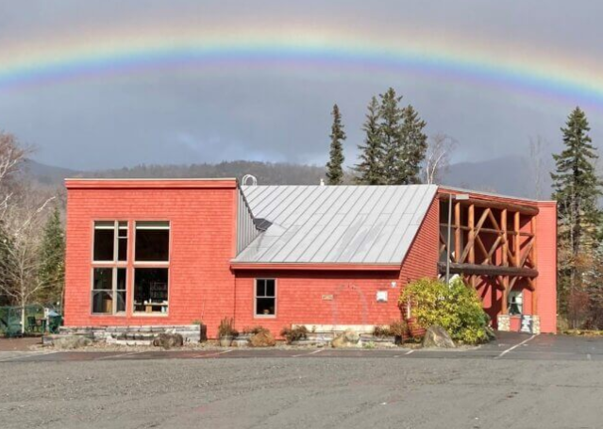
Library Member Services are free and include highspeed Internet access, 24/7 WiFi, access to free streaming services, ebooks and audiobooks, DVD and Kindle lending, and Interlibrary Loan (ILL). The library provides patrons with access to over 13,000 items in-house and thousands more in the form of ebooks, audiobooks, and streaming services from Kanopy, as well as free or discounted admission passes to the Maine State Parks, Western Maine Play Museum, and the Children’s Museum of Maine.

The Town owns the library facility and pays the salary of one full time staff member. A portion of the building is used as a non-profit child-care center, which receives free rent and utilities from the town. The lobby of the facility offers space for people to drop in and work at tables and check emails, or to enjoy the artwork displayed on the walls that changes monthly and features local and statewide artists. The building also offers the Begin Room which is used for public meetings, educational programming, and community support programs such as AARP Tax Preparation Help in the spring and similar functions.

Information Center
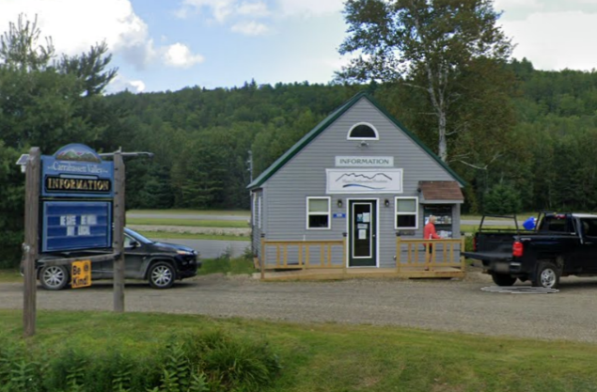
The Information Center is a 480 square feet building built in 1988 to serve the former Chamber of Commerce. A prior goal was to improve domestic water and sewer at this location. In 2020, the Town installed a domestic water drilled well, added a septic system and renovated the Center to make the space more usable and update the bathroom to ADA standards for staff and guests. The Town is considering adding an addition to create space for a museum that would showcase the history of the Town.

Ski & Snowboard Museum of Maine

The Ski Museum of Maine is a non-profit organization with a mission to “celebrate, preserve and share the history and heritage of Maine skiing and snowboarding.” The Maine Ski and Snowboard Museum is a non-profit organization that was founded in 1995 by a small group of friends from the Sugarloaf Ski Club. In 2022 the museum moved from Kingfield to space provided by Sugarloaf on the Access Road at Sugarloaf.

CEMETERY

The Carrabassett Valley Cemetery is approximately three acres, located in a very picturesque and quiet location between the airport and the Carrabassett River. To date, only a small number of people have been buried there so the land is sufficient in size to accommodate the town for many years.

CLIMATE AND SUSTAINABILITY

Over the last 12 years there have been four flood episodes, two of which occurred in 2023, and the 100-year floods are increasingly more common. While the flooding hasn’t affected any of the municipal buildings, it caused damage to Outdoor Center Timber Harvest roads and Nordic and Mountain Bike Trails, the Narrow Gauge Pathway, the shoreline of Riverside Park, and a portion of the tennis courts.

Current resilience measures implemented in recent years include installing a 25-kilowatt generator at the Outdoor Center lodge that serves as a warming station or disaster center as well as a high-capacity generator which enables the new mountain fire station to be a disaster command center.

Town leaders have been considering ways to make the Town facilities more resilient to flooding and other climate impacts. The Town is making an effort to keep new development out of the flood zone and considering redrawing the 100-year flood lines, which are now more like 20-year floods. (FEMA is in the process of redrawing and redefining some of their flood lines). The Town is also considering making more permanent repairs on the Narrow Gauge pathway. The Town relies on users and community members to report storm damages on the trails.

MUNICIPAL PROPERTIES

Municipal Property | Address
Jones Public Lot | East Side of Carrabassett River
Carrabassett Valley Town Office  Valley Fire Station  Northstar Ambulance Base  CV Town Park & Pool | 1001 Carriage Rd
Info Center | 1216 Carrabassett Dr
Sugarloaf Regional Airport | 1220 Carrabassett Dr
Airport Trailhead Parking Lot | 1240 Carrabassett Dr
EMS/Fire Radio Repeater | Hutchins Circle in Redington North
Campbell Field Trailhead Parking Lot | Campbell Field Trailhead
CV Public Lot & Sugarloaf Outdoor Center | 3001 Outdoor Center Rd
Anti-Gravity Center | 3207 Carrabassett Dr
CV Public Library, Community Center, and Western Maine Center for Children | 3209 Carrabassett Dr
CV Police Department & Sugarloaf Security | 9000 Main St
Sugarloaf Golf Course & Clubhouse | 5071 West Mountain Road
CV Transfer Station | 4056 Carrabassett Drive

Utility & Service Property | Address
Maine Huts & Trails Stratton Brook Parking Lot | 4008 Bigelow Station
CV Sanitary District | 4064 Carrabassett Dr
Sugarloaf Water Association | 5005 Iron Brook Rd
CMP Bigelow Substation | 40xx Carrabassett Dr
Maine Ski & Snowboard Museum Site | Sugarloaf Access Rd
Sugarloaf Garage Cell Tower | 7001 Bucksaw Road
Sugarloaf Summit Cell Tower | Sugarloaf Summit
Transfer Station Cell Tower | 4056 Carrabassett Dr

State & Federal Property | Address
MDOT Seasonal Rest Area | Leased Land along Carrabassett Drive
Maine BPL Reserve Land abutting Bigelow Preserve | In the woods
Homeland Security Tower & Maine State Police | Sugarloaf Summit
Appalachian Trail | Caribou Pond Rd & ME Route 16/27

MAPS

Figure 1. Carrabassett Valley Land Ownership Map
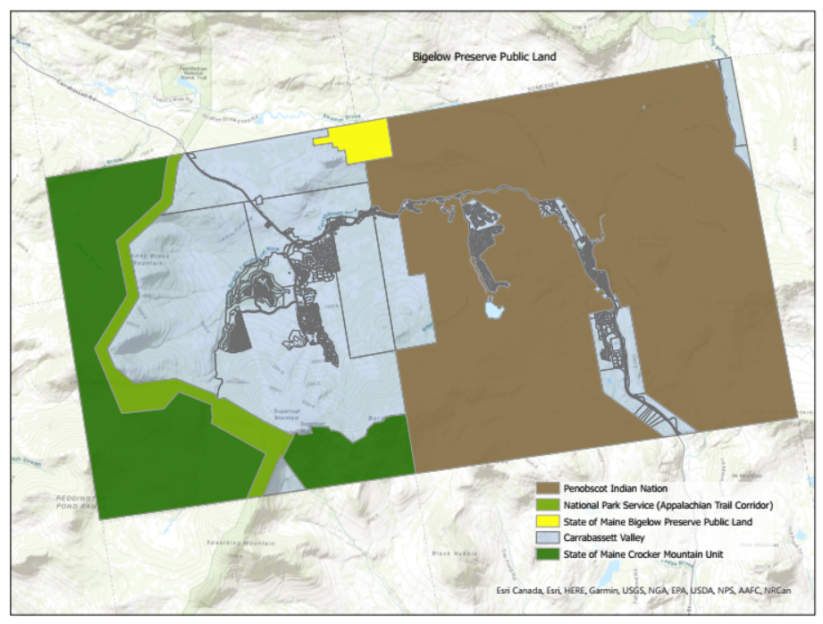

Figure . Map town-owned properties

Figure . Map of cell towers (Do we want this to be a separate map? They are in the kmz file of town-owned properties)

Figure . Carrabassett Valley Sanitary District Service Area

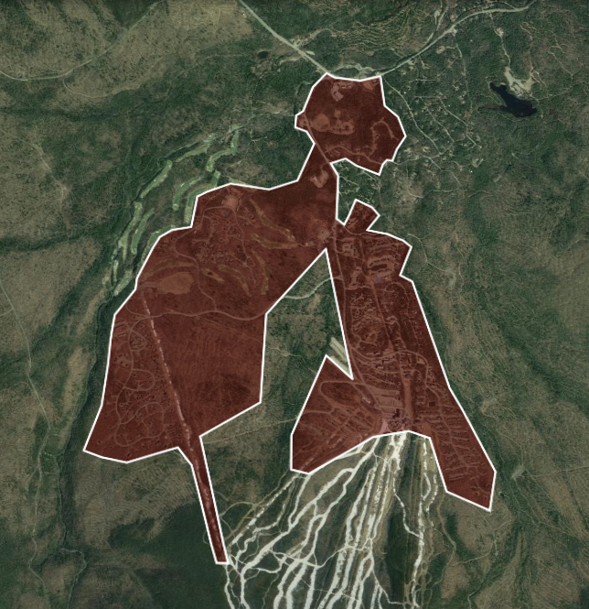

Figure . Sugarloaf Water Association Service Area

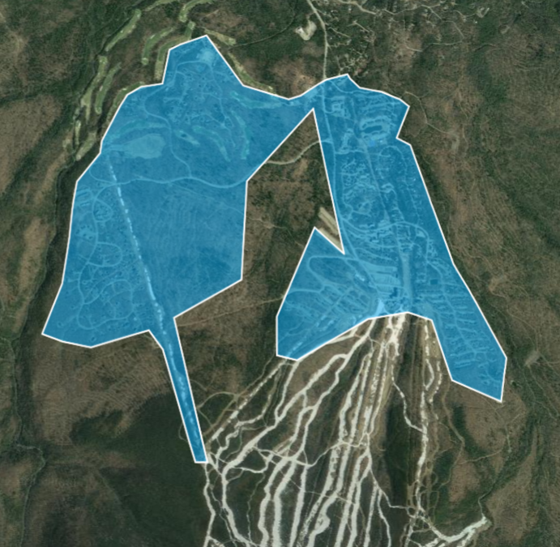
Figure . Sugarloaf Water Association Service Area Boundary

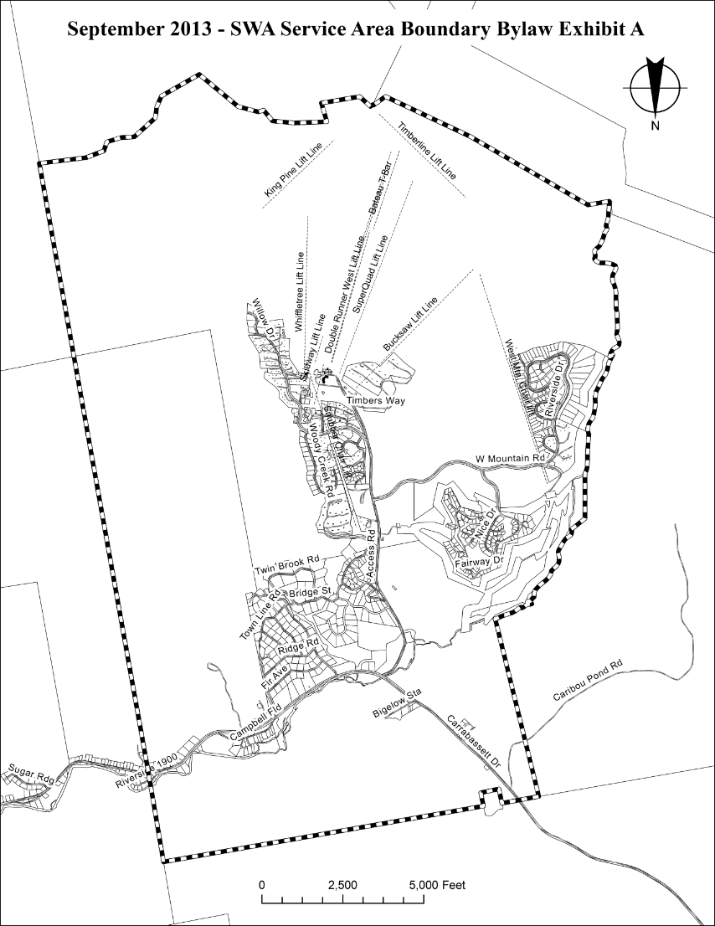

Figure . Sugarloaf Water Association Pressure Zones
