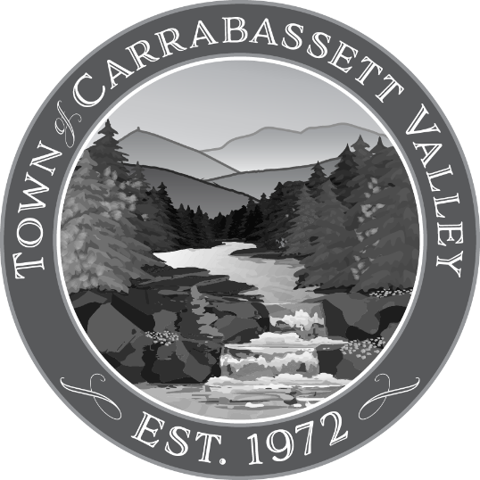
Town of Carrabassett Valley
Notice of Public Hearing
Concerning Request for Marijuana Retail Store License Renewal

The Town of Carrabassett Valley Select Board will hold a Public Hearing at 4:30 p.m. October 23, 2023, at the Town Office to consider approval of a Marijuana Retail Store License Renewal for Green Alien Cannabis Company doing business as Cannabis Cured at 1215 Carrabassett Drive.

A copy of the application can be viewed at the Carrabassett Valley Town Office or at the Public Hearing.

