THE CARRABASSETT VALLEY RECREATION DEPARTMENT IS NOW ACCEPTING PROSPECTIVE APPLICANTS FOR OUR SUMMER POOL OPERATIONS
@THE SAMANTHA WRIGHT MEMORIAL POOL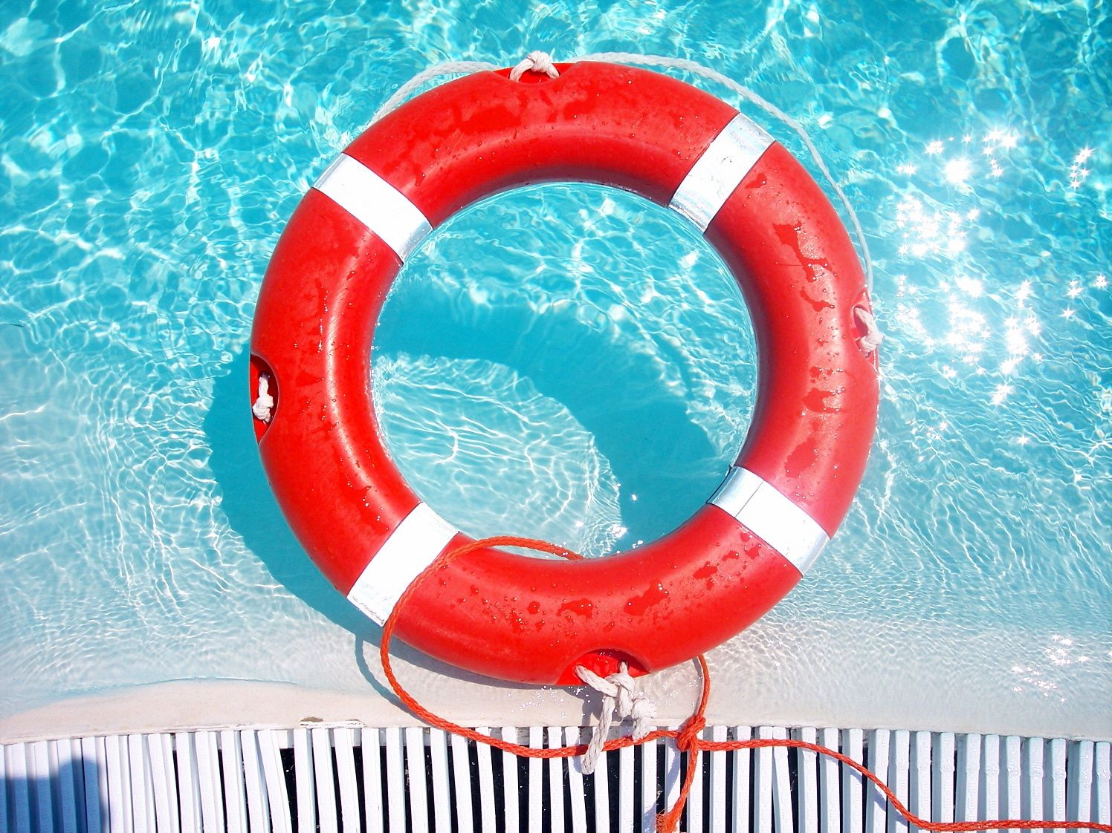
WATER SAFETY INSTRUCTORS & LIFEGUARDS
FMI candidates, please contact: dbowker3@roadrunner.com

