The place to be on wind hold days, rainy days, freezing cold days…
Or any day!

Annual Membership
Winter Schedule
Monday through Thursday:
6:00 - 10:00 am and
3:00 - 9:00 pm
Friday:
6:00 - 10:00 am and
4:00 - 9:00 pm
Saturday:
6:00 am - 1:00 pm and
4:00 - 9:00 pm
Sunday:
7:00 am - 9:00 pm

Access to the fitness mezzanine, skate park and skate bowl, downstairs fitness room and basketball court!

Carrabassett Valley Taxpayer
Individual Membership $100.00 Family Membership $235.00
MSAD #58 Membership $100.00

Non-Taxpayer Rate
Individual Membership $150.00

Family Membership $310.00
(Two adults, three children)

Daily Rates Available:
$7.00/youth (under18 years)
$10.00/adult
Multi-Passes are also available

www.carrabassettvalley.org 207.237.5566

Carrabassett Valley Recreation Department

Carrabassett Valley Anti Gravity
Recreational Complex

Defying Gravity Since 2001

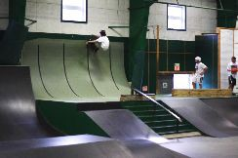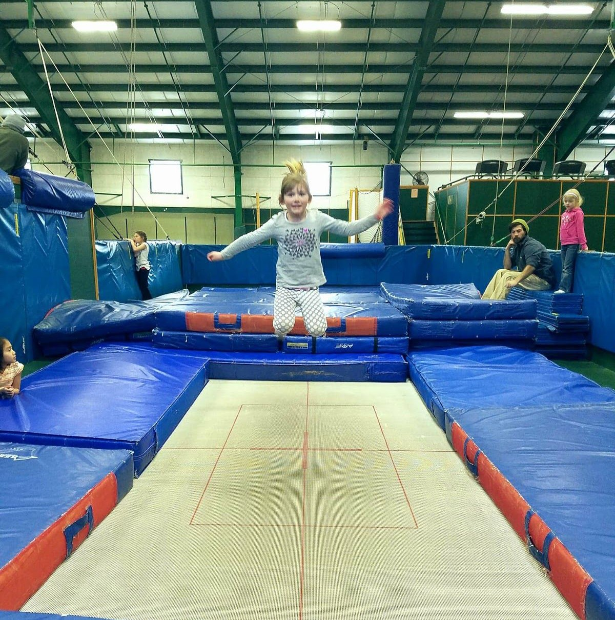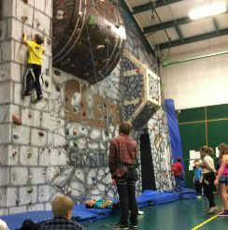Basketball Court-Fisher Gym

Clem’sClimbing Wall Fitness Mezzanine

Dupree Skate Park & Bowl

Olympic Trampolines
Pilates
Pound Class
Personal Fitness Training Strength in Weights

Olympic-Size Trampolines

Clem’s Climbing Wall

2- Olympic-sized trampolines Maximum 10 people
Public Trampoline begins on Friday Nov. 22 Ages 5+ ($7 youth, $10 adult)
Private Lesson’s $70.00 hour
Dupree Skate Park
Ages 5+ Daily Rate ($7 youth, $10 adult)
Private Skate lesson for 3 people or less $55.00 hour

Climb high at Clem’s Climbing Wall with our 35-foot wall. Set routes for all abilities.
Public climbing begins on Friday Nov. 22
Ages 4+ ($7 youth, $10 adult)
Or call us for A
Private Lesson’s $70.00 hour Maximum 4 people

