Plymouth Engineering, Inc.
P.O. Box 46 – 30 Lower Detroit Road
Plymouth, Maine 04969
info@plymouthengineering.com
Tel: (207) 257-2071 fax: (207) 257-2130

November 10, 2011 | Project No. 11161

Mr. David Cota, Town Manager
Town of Carrabassett Valley
1001 Carriage Road
Carrabassett Valley, ME 04947

Sugarloaf Golf Course – Report of Findings for Flood-Related Repairs

Dear Mr. Cota:

Plymouth Engineering, Inc. is pleased to submit this letter to serve as a summary of our findings, recommendations and conceptual cost estimates for repairs to various areas of the Sugarloaf golf course that were damage by tropical storm Irene (Irene). We have visited the site with you and Bill Gilmore, Code Enforcement Officer as well as a member of the course’s greens committee. Our site visit and follow-up information addresses the following areas of the course:

- Bridge and River Bank between holes 10 and 11;
- Bridge and River Bank near the 12th tee;
- Bridge and River Bank near the 14th green;
- Bridge and River Bank near the 15th green.

All of these areas were significantly affected by erosion of river bank and bridge abutment area during the flood stage runoff from Irene. Most of the damage as expected is in areas where the river bends and/or has a constricted cross-section. The following paragraphs summarize our findings, recommendations and cost estimates for repairs to the impacted areas.

General Remedy: In general, the repairs to the embankments will consist of re-establishing a consistent embankment shape, placing geotextile fabric, and placing heavy rip rap to a uniform slope. The rip rap should have an average diameter (d50) of two to three feet. Actual slope stability analyses have not been completed. The selection of the stone size is based on the existing conditions and the rip rap slopes that were not damaged during the flood waters. Additionally, the rip rap proposed should be angular to sub-angular stone. Much of the original stone was derived from the golf course construction and was more round than desirable. This shape results in a tendency to roll with high flood waters. We further recommend that the stone be placed no steeper than a 1:1 slope. Some areas can be flatter, but some, due to the narrow river cross-section will have to be 1:1 to avoid encroaching into the river cross-section

Bridge and river bank between holes 10 and 11: This area, as shown in the photos in Appendix A has a narrow and steep cross-section. The flood waters actually topped the bank on the hole 10 side of the bridge and eroded the approach as well as rip rap embankment upstream and downstream of the bridge. Erosion of material around the bridge abutment will require that a portion of the bridge deck be removed to repair the rip rap embankment. The average embankment height in this area is approximately eleven feet high and the overall length of repairs is approximately 125 feet.

Bridge and river bank near hole 12 tee: This area has what appears to be the most extensive damage. The pre-existing 85-foot free span bridge to the men’s tee boxes was completely destroyed including destruction of the timber-crib abutments. Together with the bridge destruction, there is approximately 275 feet of river bank that was damaged. Much of that length was rip rapped, and all will not have to be rip rapped. The average embankment height in this area is 7-9 feet. The photos in Appendix B show the area that was previously the bridge and the eroded embankment.

Bridge Approach and river bank near 14th green: Hole 14 is unique in that the upstream damage as the floodwaters approach the bridge consisted of existing stone being spread somewhat laterally to flatten the slope. The downstream erosion literally eliminated the embankment revealing a vertical soil face. The embankment in this area of repair is approximately 120 feet long with an average height of some 12 feet. The abutment on the cart pat side of the bridge will very likely have to be replaced in order to repair the embankment to the necessary height and slope. The photos in Appendix C depict the severe erosion especially downstream.

River Bank near hole #15 green: The area near the 15th green bridge is somewhat different than the other three areas of damage. The river cross-section at this location is significantly wider and even branches around the 15th green. As such, the primary issue here is the rolling of embankment stone into the river bottom. We recommend that this stone be picked and replaced to the embankment. This can be accomplished with a sizable excavator located on the shore. The embankment is still intact, and there are no large areas of exposed soil as with the other areas.

COST ESTIMATING

Based on our observations at the site, and the summary of conditions above, Plymouth Engineering has developed a conceptual opinion of costs to perform the repairs discussed above. Our cost estimate omits the costs for any actual bridge work except for the deck removal/replacement at hole 10/11. We have, as requested, amended our cost estimate to include the engineering costs anticipated to prepare a bid package for the work to be undertaken. That package will be based on typical embankment cross-sections and rip rap details along with performance specifications for the hole #12 bridge replacement.

We hope the information contained in this report provides you adequate data to seek assistance with the repair costs from Irene. As you move forward if there is anything else we can do to assist you please call us.

Sincerely,
Plymouth Engineering, Inc.



Scott E. Braley, PE, CPESC
President

APPENDIX A
HOLE #10/#11 CROSSING

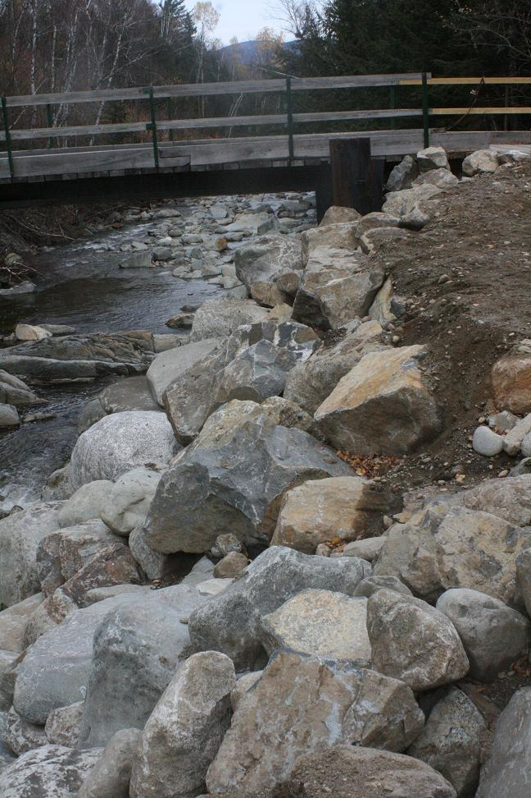

HOLE 10/11 BRIDGE ERODED UPSTREAM BANK
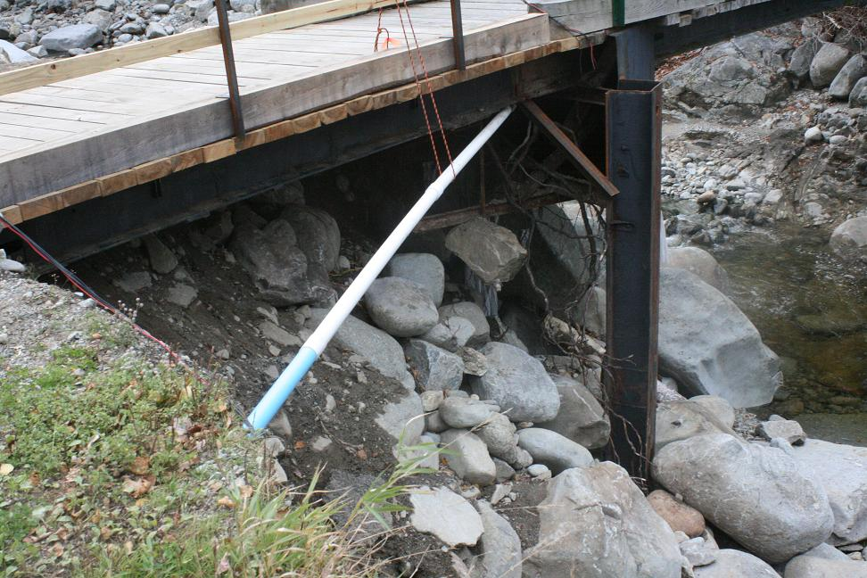
HOLE 10/11 BRIDGE ABUTMENT ERODED RIP RAP EMBANKMENT
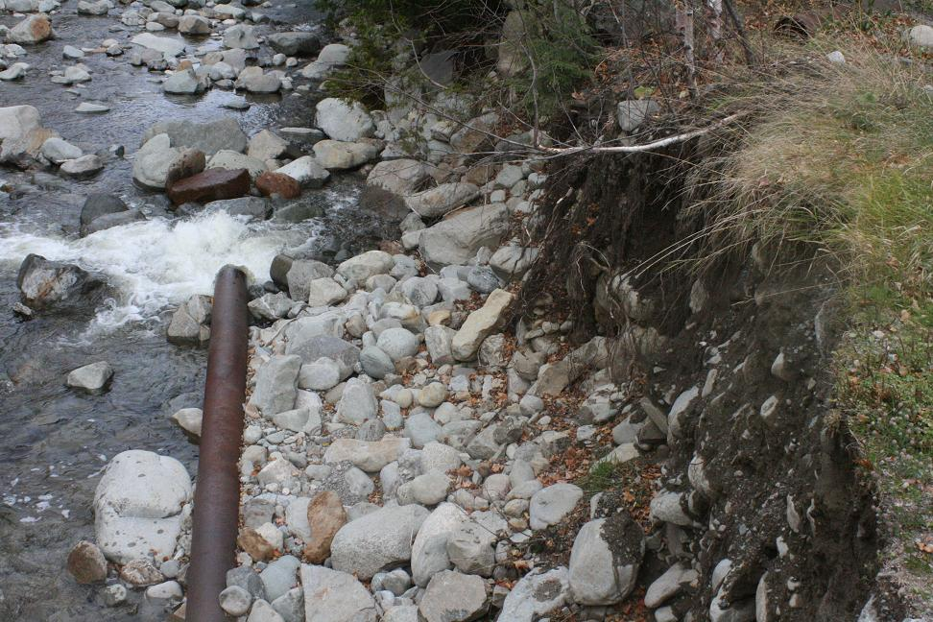
HOLE 10/11 DOWNSTREAM EMBANKMENT EROSION
APPENDIX B
HOLE #12 TEE AREA

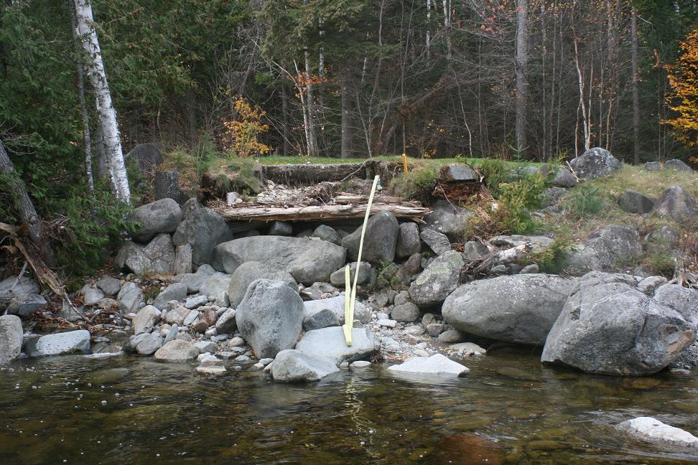
HOLE 12 TEE SIDE OF DESTROYED BRIDGE / ABUTMENT

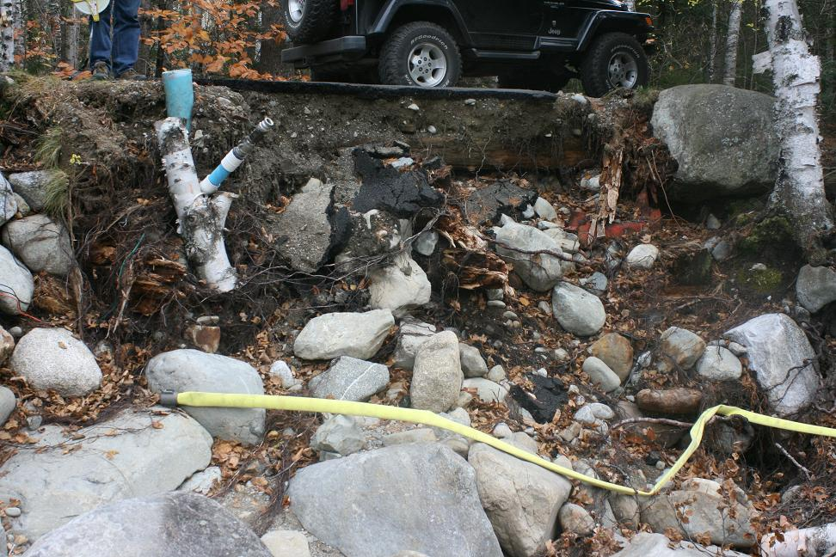
HOLE 12 BRIDGE AND ABUTMENT ON CART PATH SIDE OF BRIDGE

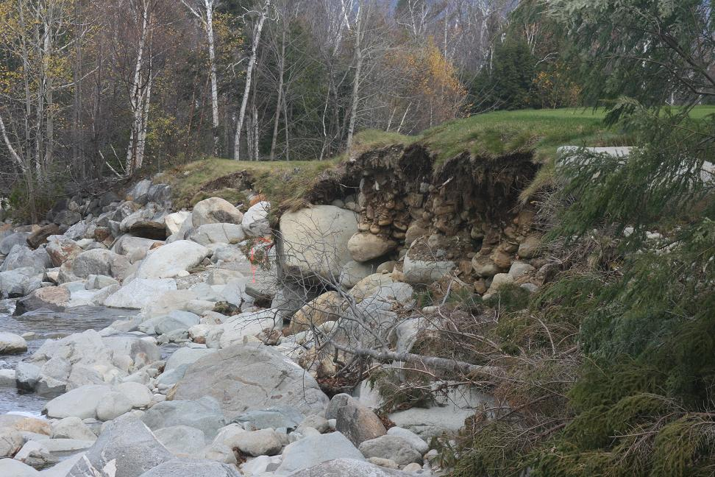
HOLE 12 DOWN STREAM EROSION OF EMBANKMENT

APPENDIX C
HOLE 14 BRIDGE APPROACH

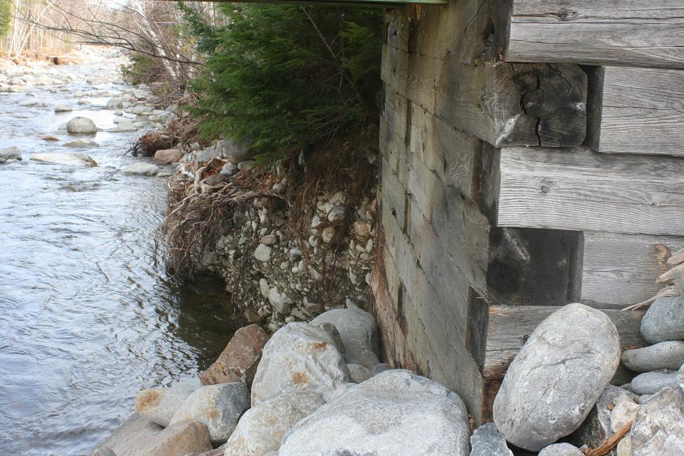
HOLE 14 VIEW FROM ABUTMENT DOWNSTREAM

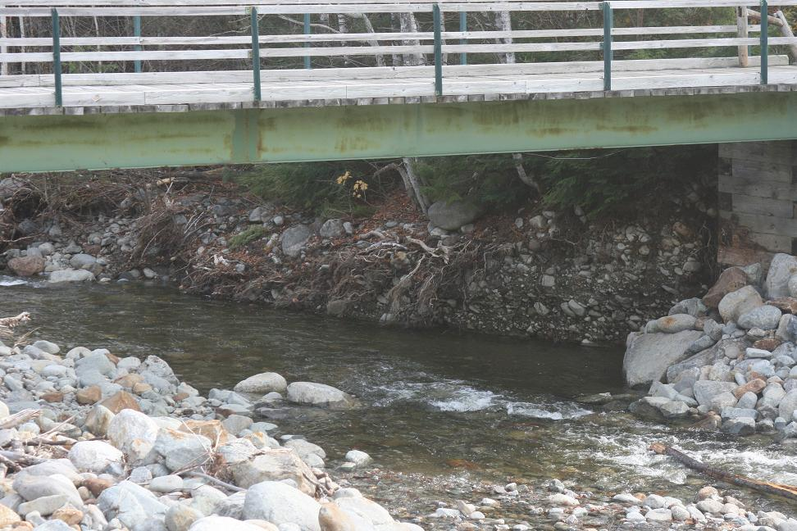
HOLE 14 DOWNSTREAM DAMAGE

APPENDIX D
PRELIMINARY COST ESTIMATES

Town of Carrabassett Valley
Sugarloaf Golf Course Repairs - Job #11161
11/4/2011 | rev'd 11/10/11
Item |  | quantity | unit cost | item cost
Hole 10/11 Bridge
 | slope prep work (hourly) | 8 | $ 175 | $ 1,400
 | riprap (cy) | 300 | $ 70 | $ 21,000
 | deck work (lump sum) (1) |  |  | $ 3,000
 | filter fabric work (square yard)(3) | 315 | $ 5 | $ 1,575
Hole 12 tee area
 | slope prep work (hourly) | 16 | $ 175 | $ 2,800
 | riprap (cy) | 425 | $ 70 | $ 29,750
 | filter fabric work (square yard)(3) | 490 | $ 5 | $ 2,450
 | rebuild 12th ladies tee |  |  | $?
 | new bridge (2) |  |  | $?
Hole 14 river bank/bridge approach (5)
 | slope prep work (hourly) | 8 | $ 175 | $ 1,400
 | riprap (cy) | 360 | $ 70 | $ 25,200
 | filter fabric work (square yard)(3) | 325 | $ 5 | $ 1,625
 | abutment replacement (3) |  |  | $?
Hole 15 slope reshaping (hourly) (4)
 | Cat 330 | 16 | $ 175 | $ 2,800
Engineering Design Assistance to include |  |  |  | $ 3,900
 | rip rap embankment details
 | performance specifications for hole #12 bridge
 | bid package for design/build bidding
Engineering Monitoring During Construction
 | based on 10 visits | 80 | $ 75 | $ 6,000
 | mileage | 1500 | $ 0.55 | $ 825
(1) | to remove deck extension and some original deck to place rip rap through bridge
 | one day to remove and one day to replace per telcon w/Justin Jordan on Nov 4, 2011.
(2) | Field measurements and discussions for a 6-foot wide by 85-foot long bridge for
 | foot traffic and light equipment. Additional swing down stiffeners could
 | be added to the design / construction for mid span support of heavier equipment.
(3) | This cost reflects ONLY the side that is required for repair to undertake rip rap work.
 | If the Town intends to replace both ends and/or the bridge itself that cost is likely not
 | reimbursable from flood damage monies.
(4) | There are several areas of the project and particularly hole 15 where stone has been
 | rolled by the storm to the foot of slope or into the river thus reducing the effective cross-sectional
 | area of the river for typical and flood flows to pass. We recommend that these stone be
 | placed back on the embankments as part of this work. We recommend this be done on an
 | hourly basis with a large machine that has both reach and power such as a 330 Cat or equal.
(5) | This cost reflects approximately 275' of repair from the bridge to below the ladies tee.
General Notes:
1. All estimates based on field measurements of approximate heights assuming a 1:1 finish slope (45 degrees).
2. This cost estimate does not include and repairs to the golf course surface itself if damaged during river bank repair work.

